**My Story in Implementing Cloud Security Measures**

**The Beginning:**

As a student pursuing a Higher National Diploma in Cloud Computing, I was tasked with designing a secure cloud-based system and implementing necessary security measures to protect and deploy a website. This project was part of the "Cloud Security" course and aimed to apply theoretical knowledge in a practical setting.

The First Challenge: Understanding Principles and Standards:

I began my journey by reviewing fundamental security principles and globally recognized security standards. I learned the importance of standards like CSA CCM, NIST, and ISO 27001 in protecting cloud infrastructure. I realized that these standards help in:

* Reducing the risk of security breaches.
* Ensuring compliance with laws and regulations.
* Protecting an organization's reputation.

With this understanding, I was able to determine how to use these standards to build a secure cloud system.

**Designing a Secure Cloud Solution:**

Relying on the knowledge I acquired, I designed a comprehensive system to migrate a website to a cloud environment. The plan included:

1. Protecting client data: By utilizing Web Application Firewalls (WAF) and Access Control Lists (ACLs) to ensure information security.
2. Ensuring continuous service availability: By setting up an Auto Scaling group to maintain service even in case of disasters.
3. Compliance with standards: By defining strict security rules to protect data.
4. Dynamic scalability: By using a Load Balancer to efficiently distribute traffic.

**Practical Implementation:**

I began executing the plan by:

* Setting up multiple servers in different availability zones.
* Configuring Load Balancers to ensure efficient traffic distribution.
* Implementing SQL Injection and Bot Control rules to protect the application from advanced threats.
* Using AMI Templates to automatically provision new servers.

**Testing and Evaluation:**

Once the implementation was complete, I conducted comprehensive tests to assess the effectiveness of the solution. The tests included:

1. Server Security Testing (Security Groups):

* Ensuring access was restricted to authorized ports only.
* Simulating unauthorized access attempts.

1. Load Balancer Testing:

* Using tools like JMeter to test load handling capacity.
* Measuring response times and error rates.

1. Access Control List (ACL) Testing:

* Simulating attacks such as SQL injection and bot attacks.
* Reviewing activity logs to detect suspicious behavior.

1. Auto Scaling Testing:

* Increasing server instances during high traffic.
* Reducing resources during low traffic to ensure efficiency.

**Results and Recommendations:**

The tests demonstrated the system’s success in:

* Preventing unauthorized access.
* Handling large volumes of requests without interruption.
* Mitigating common attacks like SQL Injection.
* Dynamically adapting to changes in traffic.

**Lessons Learned:**

* Through this experience, I demonstrated my ability to:
* Apply theoretical concepts in a practical environment.
* Design and implement integrated cloud security systems.
* Evaluate and enhance systems based on testing results.

**Conclusion:**

This experience serves as a practical example of how students can leverage cloud computing and security techniques to deliver innovative solutions. I successfully built a secure and resilient system, showcasing my potential as a future professional in cloud security.

**Task A: Exploring Basic Security Principles and Standards**

As a cloud security engineer, you are responsible for describing the fundamental security principles commonly used in an organization's cloud infrastructure. Additionally, you are required to explain the common security standards that should be employed to ensure a secure cloud system.

**Question 1: Explain the Importance of Security Standards and Their Purpose. How Does Compliance with These Standards Enhance Overall System Security?**

**Importance of Security Standards and Their Purpose:**

Security standards are essential for protecting information and systems from unauthorized access, use, disclosure, disruption, modification, or destruction. They provide a set of best practices and guidelines that organizations can follow to improve their security posture.

There are various types of security standards, the most common of which include:

* Information Security Standards: These protect sensitive information, such as personal data, financial data, and intellectual property.
* System Security Standards: These safeguard computer systems and networks from attacks.
* Application Security Standards: These protect software applications from vulnerabilities.
* Physical Security Standards: These protect physical assets, such as buildings and equipment.

**The Importance of Security Standards:**

Security standards are crucial for several reasons:

* Reducing the Risk of Security Breaches: By adhering to security standards, organizations make it harder for attackers to access their systems and data.
* Improving Compliance with Laws and Regulations: Many laws and regulations require organizations to implement specific security measures. Security standards help organizations meet these requirements.
* Protecting Organizational Reputation: A security breach can harm an organization’s reputation, leading to loss of customers and revenue. Security standards help prevent breaches and protect the organization’s image.
* Saving Costs: Resolving security breaches can be expensive. Security standards help prevent breaches and save money.

**Cloud Security Standards:**

Cloud security standards are a subset of security standards specifically designed for cloud computing environments. Cloud computing is a model for delivering IT services online, such as storage, computing, and databases. Cloud security standards help protect cloud environments from the unique risks they face.

Examples of well-known cloud security standards include:

1. Cloud Security Alliance (CSA) Cloud Controls Matrix (CCM): A framework that outlines key cloud security controls.
2. National Institute of Standards and Technology (NIST): A catalog of security and privacy controls for information systems and organizations.
3. ISO 27001: A standard for information security management systems.
4. PAS 555: A British standard focusing on cybersecurity governance and risk management.

These standards cover various areas of cloud security, including:

* Access Control: Ensuring that only authorized individuals can access data and systems.
* Data Control: Protecting data from unauthorized manipulation, loss, or disclosure.
* Infrastructure Control: Securing cloud infrastructure from attacks and damage.
* Operations Control: Ensuring that security processes are executed correctly.

Cloud security standards are essential for organizations that use cloud computing services. They can help in:

* Protecting cloud data and systems: Cloud security standards can safeguard data and systems stored or processed in the cloud.
* Enhancing overall cloud security posture: Cloud security standards help organizations improve their cloud security posture.
* Meeting compliance requirements: Many compliance requirements apply to cloud environments. Cloud security standards assist organizations in meeting these requirements.

In addition to the general benefits of security standards, cloud security standards also help in:

* Reducing cloud-specific threats: Cloud environments face unique threats, such as data breaches and account hijacking. Cloud security standards help mitigate these threats.
* Improving cloud governance: Cloud security standards aid organizations in enhancing their cloud governance practices.
* Building customer trust: As customers become increasingly concerned about the security of their data in the cloud, cloud security standards help organizations build trust with their clients.

By adhering to security standards, organizations can improve their security posture, protect their data and systems, and comply with laws and regulations. Cloud security standards are particularly important for organizations using cloud services as they help safeguard cloud data and systems, enhance the cloud security posture, and meet compliance requirements.

<https://www.en-standard.eu/pas-555-2013-cyber-security-risk-governance-and-management-specification/>

**Question 2: Identify two commonly used security standards in cloud environments and distinguish between them based on their scope, benefits, and limitations. Then, analyze how each standard contributes to ensuring the security of cloud-based systems.**

Both NCSC (National Cyber Security Centre) and NIST (National Institute of Standards and Technology) are prominent organizations that provide cybersecurity frameworks, but they cater to different contexts and have distinct strengths and weaknesses. Let's delve into the key differences between them:

**Scope:**

NCSC: Primarily focuses on the UK government and critical infrastructure protection, but it is adaptable to any organization. Its guidelines emphasize practical steps and case studies relevant to the threat landscape in the UK.

NIST: Offers a broader scope, providing guidelines for organizations of all sizes across various sectors. Its framework provides high-level principles and best practices applicable to diverse threat environments.

**Benefits:**

NCSC:

* Tailored Guidance: Offers advice and resources specific to certain sectors, making it easier for organizations to implement relevant controls.
* Practical Insights: Focuses on actionable steps and real-world scenarios, facilitating immediate implementation.
* Government Backing: Provides confidence and credibility due to its association with the UK government.

NIST:

* Flexibility: Allows customization according to individual needs and risk profiles.
* Global Recognition: Widely accepted and referenced by governments and organizations worldwide.
* Ongoing Updates: Regularly reviewed to reflect evolving cyber threats and technologies.

**Limitations:**

NCSC:

* Limited Global Scope: Primarily relevant to UK organizations and may require adaptation for other regions.
* Less Comprehensive: Provides specific, actionable guidelines but may lack the breadth of some larger frameworks.
* Government Dependency: Subject to changes in government priorities and policies.

NIST:

* Complexity: A broad framework with numerous controls, requiring substantial effort for implementation.
* High-Level Guidance: Less prescriptive than NCSC, requiring further interpretation and customization.
* US-Focused: While adaptable, some aspects may not directly translate to non-US contexts.

Contributions to Cloud Security: The NCSC and NIST frameworks help secure cloud-based systems by:

* Risk Identification: Providing methodologies for identifying and assessing threats specific to cloud environments.
* Implementation Controls: Recommending security controls that cover areas like data encryption, access management, and incident response.
* Promoting Best Practices: Highlighting cloud security best practices, including configuration management, patching, and logging.

However, there are some nuances:

NCSC: Provides specific guidelines on cloud security, including Cloud Security Principles, tailored to threats and regulations in the UK.

NIST: Offers broader guidance focusing on the cloud through its special publication 800-160, which applies to diverse cloud scenarios.

**Choosing the Right Framework:**

The choice between NCSC and NIST depends on various factors, including:

1. Organizational size and sector: Smaller organizations may prefer the practical guidance offered by NCSC, while larger organizations may benefit from NIST's flexibility.
2. Geographical location: NCSC is better suited for UK-based organizations, while NIST has global applicability.
3. Regulatory compliance: Specific regulations may mandate the use of one framework over the other.

Ultimately, both NCSC and NIST provide valuable frameworks for enhancing cybersecurity. Their differences should be carefully considered to choose the one that best aligns with your organization's unique needs and context.

<https://www.ncsc.govt.nz/resources/ncsc-cyber-security-framework/> .

<https://www.nist.gov/cyberframework> .

<https://www.ncsc.gov.uk/collection/cloud/the-cloud-security-principles> .

<https://csrc.nist.gov/pubs/sp/800/160/v1/upd2/final> .

**Question 3: Cryptographic hashes and digital certificates are widely used technologies that play a crucial role in security systems. Precisely define how these principles support security services in a cloud environment.**

Both cryptographic hashing and digital certificates serve as fundamental building blocks for cloud security, working together to ensure data integrity, authentication, and trust within the cloud environment. Here are the details of their specific roles and how they support security services:

**Cryptographic Hashing:**

Hashing functions like digital fingerprints. They take any digital data (file, message, etc.) and generate a unique, fixed-length string called a "hash" regardless of the data size or format. Any change in the data results in a completely different hash value.

This allows cloud services to:

1. Verify file and application integrity: Downloaded files, software updates, and cloud storage objects can be verified against their original hashes to ensure they have not been tampered with or corrupted during transit or storage.
2. Detect malware and intrusions: Malicious actors often modify code or files. By tracking hash changes over time, unusual deviations can alert security systems to potential attacks.
3. Securely store passwords: Hashing is used to store user passwords without revealing the actual password. When a user logs in, their login attempt generates a hash, which is compared to the stored hash. This protects passwords from theft even if attackers gain access to the database.

**Digital Certificates:**

A digital certificate is an electronic document issued by a trusted third party that establishes a link between the identity of a specific party and a pair of keys – one public and one private. It verifies the ownership and authenticity of a website, server, or user. It binds the public key (used for encryption) to the identity of the entity, enabling secure communication.

Digital certificates can be used to ensure security in the cloud environment in several ways:

1. HTTPS and TLS security: Digital certificates are the foundation of HTTPS and TLS protocols, securing the connection between web browsers and tracking data, and protecting sensitive information such as login credentials.
2. Trust and verification: Digital certificates require trust and verification from trusted certificate authorities (CAs), allowing users to interact with cloud services with confidence.
3. Identity verification: Certificates verify the legitimacy of cloud services and users, preventing unauthorized access and identity theft.
4. Man-in-the-middle attacks: Certificates thwart attackers who try to intercept communications by ensuring data is encrypted using the correct keys.
5. Encryption: Public key encryption, facilitated by digital certificates, enables communication by encrypting data using the public key for the intended recipient, ensuring only the intended recipient can decrypt it.

<https://www.nist.gov/publications/digital-signature-standard-dss-2> .

<https://www.techtarget.com/searchsecurity/definition/digital-certificate> .

<https://www.encryptionconsulting.com/digital-signature-vs-digital-certificates/> .

<https://www.cloudflare.com/learning/ssl/how-does-ssl-work/> .

<https://csrc.nist.gov/projects/hash-functions/nist-policy-on-hash-functions> .

<https://cloudsecurityalliance.org/> .

**Task B: Designing a secure cloud system and configuring the necessary cloud security measures**.

Given your acquired knowledge of common security principles and fundamental security standards, you now possess the expertise to design a cloud-based solution. Assume you have been tasked with migrating an existing website, which will be provided to you, to a cloud environment. Part of your responsibility is to design a secure cloud solution for deploying this website in a safe and robust manner. Additionally, you have been tasked with configuring the necessary security measures and resilience resources for this system.

1. When you begin the planning phase for designing a secure cloud-based solution for deploying the website, you are about to select the appropriate resources, including security services, technologies, and protocols, to arrive at a suitable and effective solution.

**A. Explain how resource considerations influence your planning for a secure cloud solution, providing sound reasons for these considerations.**

I have 4 requirements to consider for securing the website:

1. Protecting customer information from unauthorized access or modifications. I can achieve this step through a WAF and setting rules with ACLs, which allows me to ensure information security.
2. Ensuring timely provision of the ebook search service. I can achieve this requirement by adding an auto-scaling group that will add a new server if the first server receives too many requests or if the CPU reaches its limit, preventing the server from stopping and the service from being interrupted. By adding multiple availability zones, it ensures that the service remains available even if a server is damaged or a natural disaster occurs, and another server located in another zone will work instead of the damaged server without any problems, and the server will be identical to the damaged server.
3. Ensuring compliance with current data protection standards. By setting security rules that prevent intruders from stealing data.
4. Accommodating the scalable expansion of the cloud infrastructure to meet user requirements. By adding an auto-scaling group that will add a new server if the first server receives too many requests or if the CPU reaches its limit, preventing the server from stopping and the service from being interrupted. By adding multiple availability zones, it ensures that the service remains available even if a server is damaged or a natural disaster occurs, and another server located in another zone will work instead of the damaged server without any problems, and the server will be identical to the damaged server. By adding a load balancer to work efficiently.

**B. Design a secure and resilient cloud solution to deploy the provided website in a cloud environment, considering the resources you intend to incorporate into your design.**

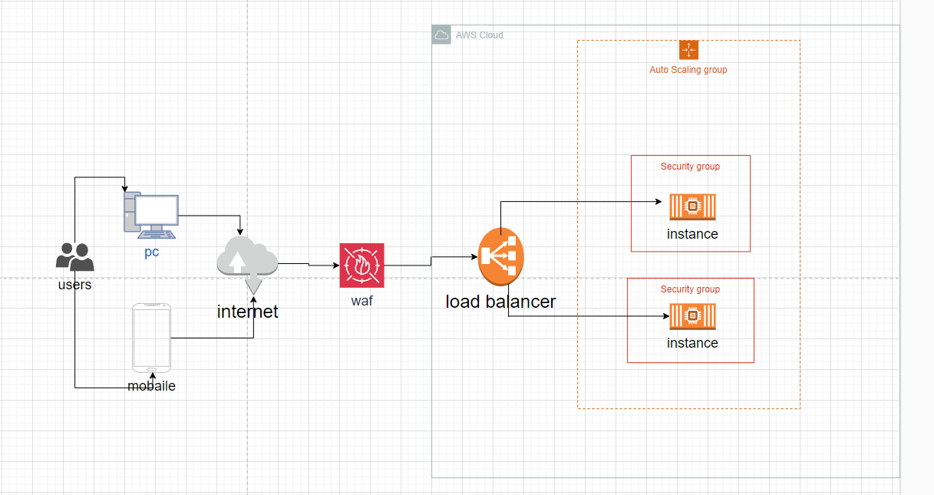

1. After developing a clear plan for your cloud security solution, your current task is to configure a number of security measures and resilience solutions to ensure the safe and robust deployment of your cloud-based system.

**A. Following your previously designed plan, you have been tasked with securely deploying the provided website on the cloud. This includes configuring a necessary set of security measures on the cloud infrastructure according to your plans.**

**B. Additionally, you have been tasked with configuring a variety of cloud-based resilience solutions within your deployment process to ensure the resilience of the cloud-based system.**

A+B:  
  
Create the first server:  
  
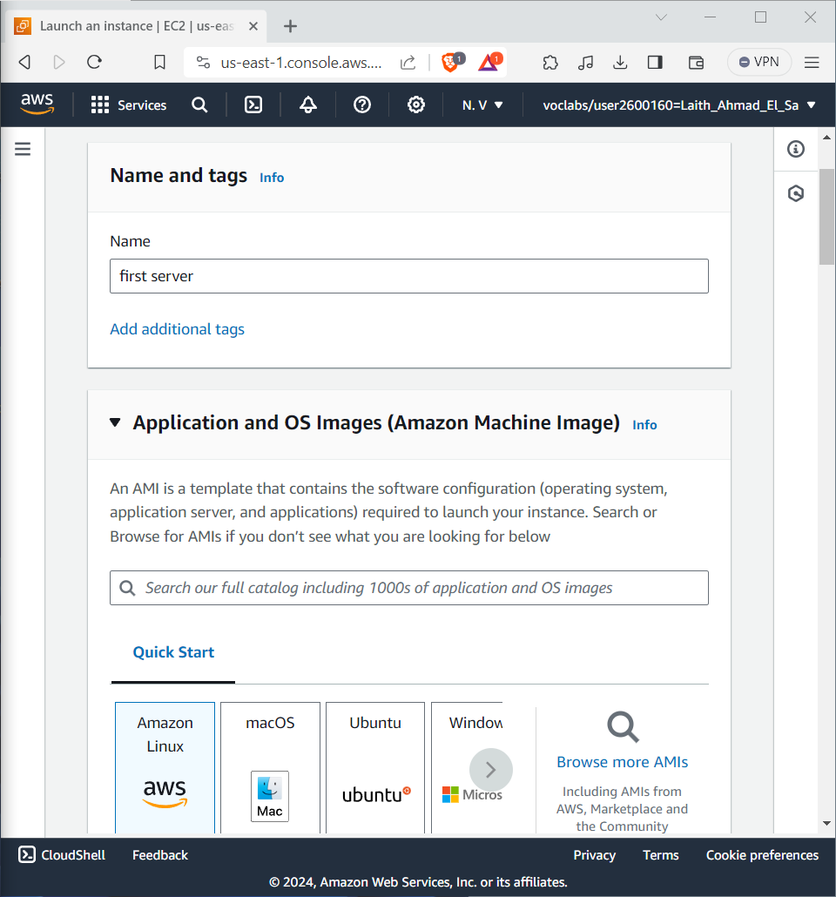  
  
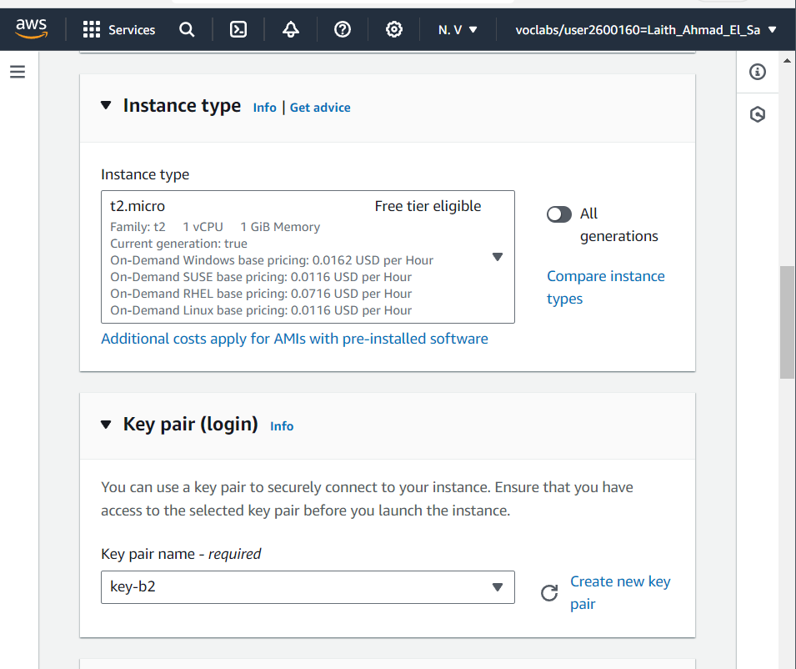

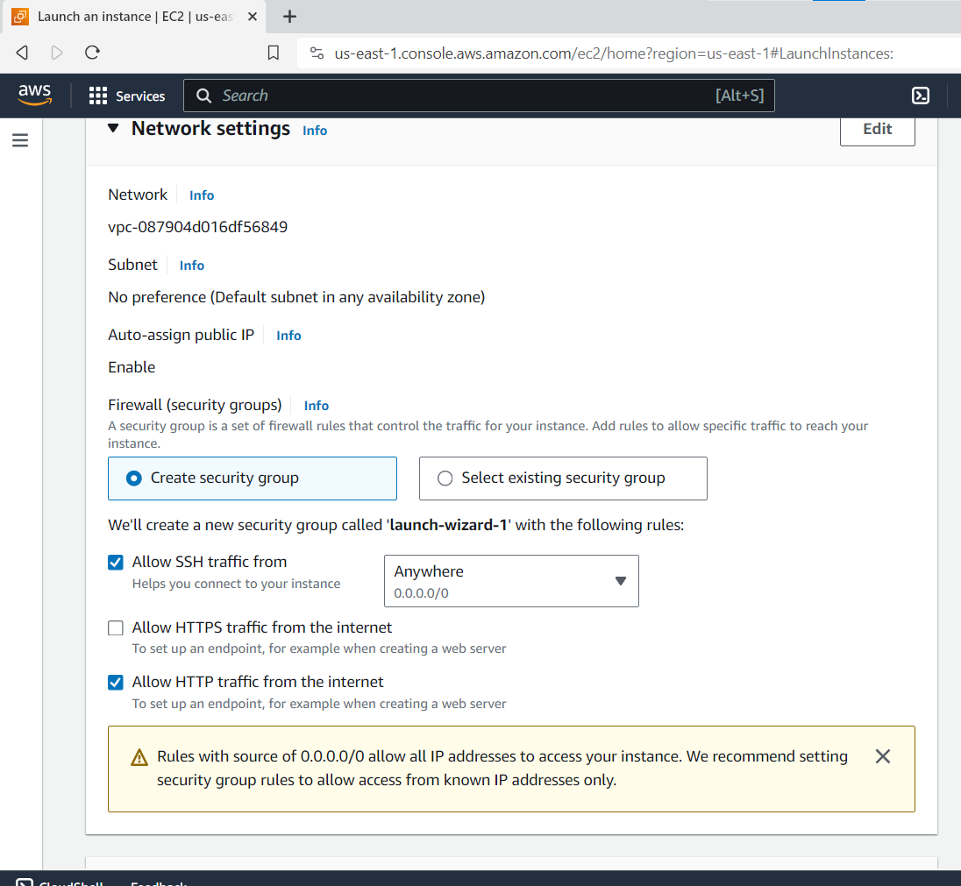

Create a Second Server:

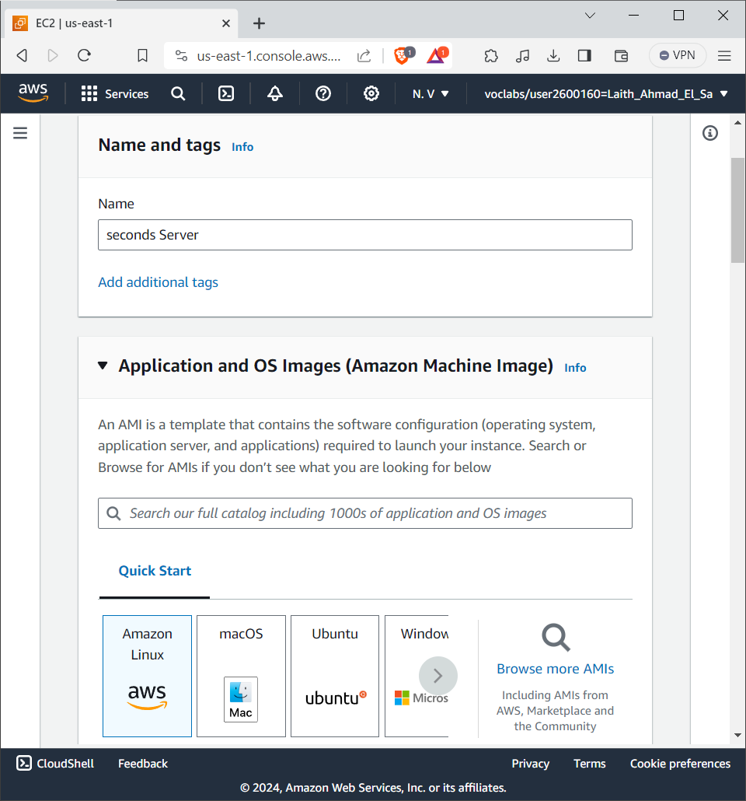  
  
  
  
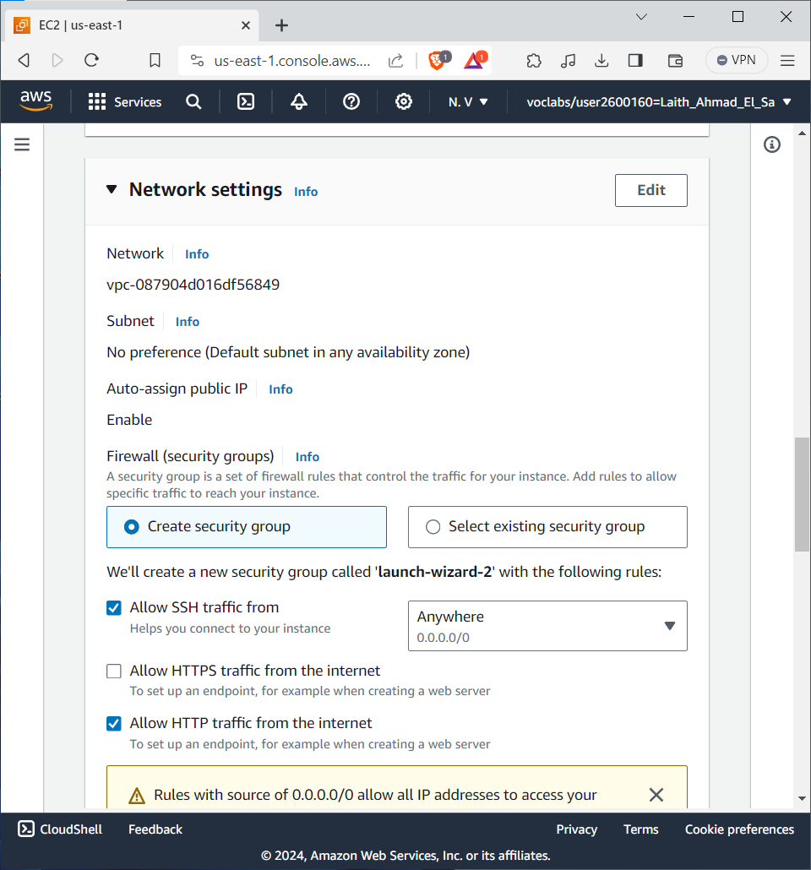  
  
  
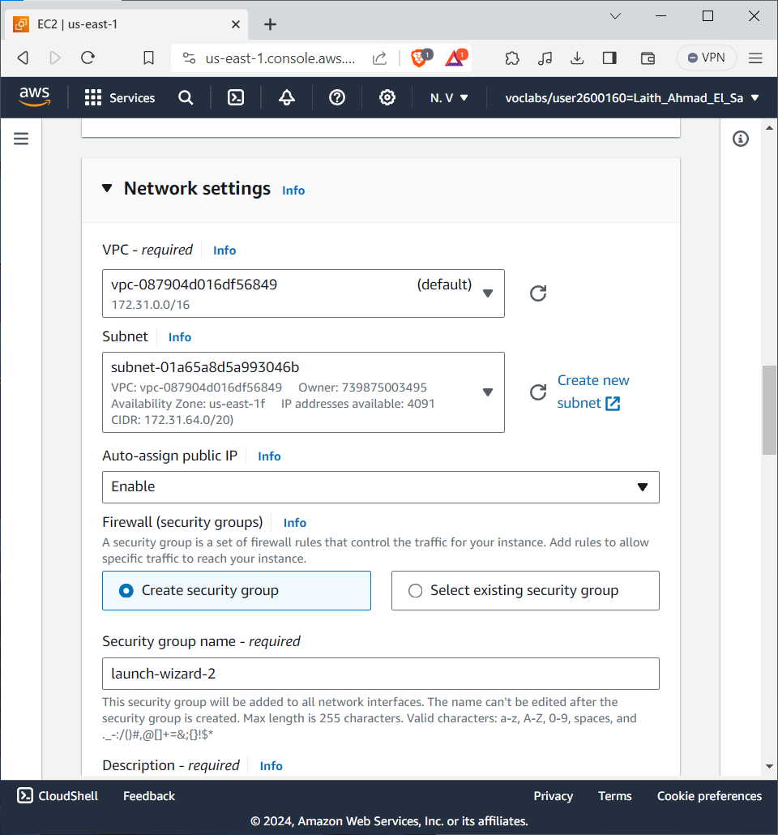  
  
  
Making Contact for First Server:

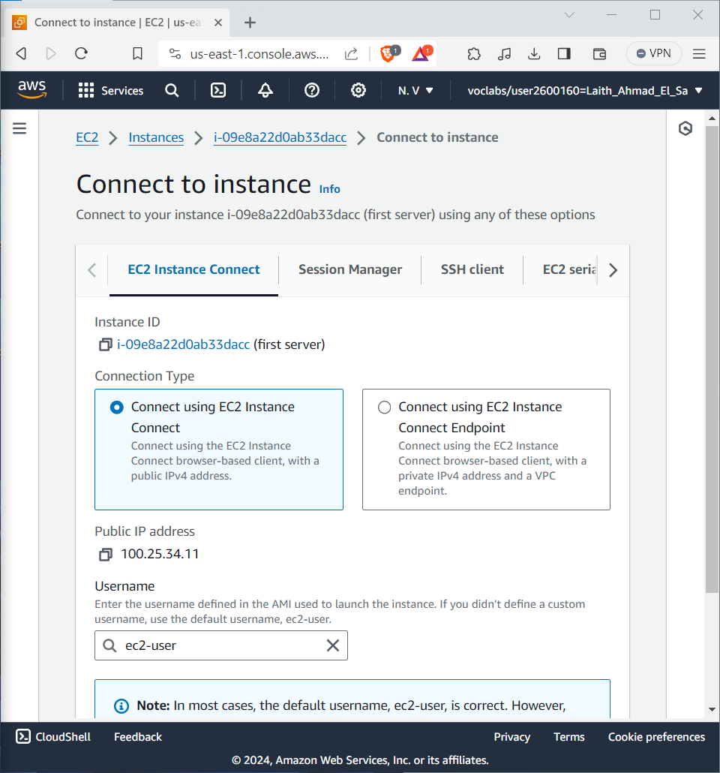  
  
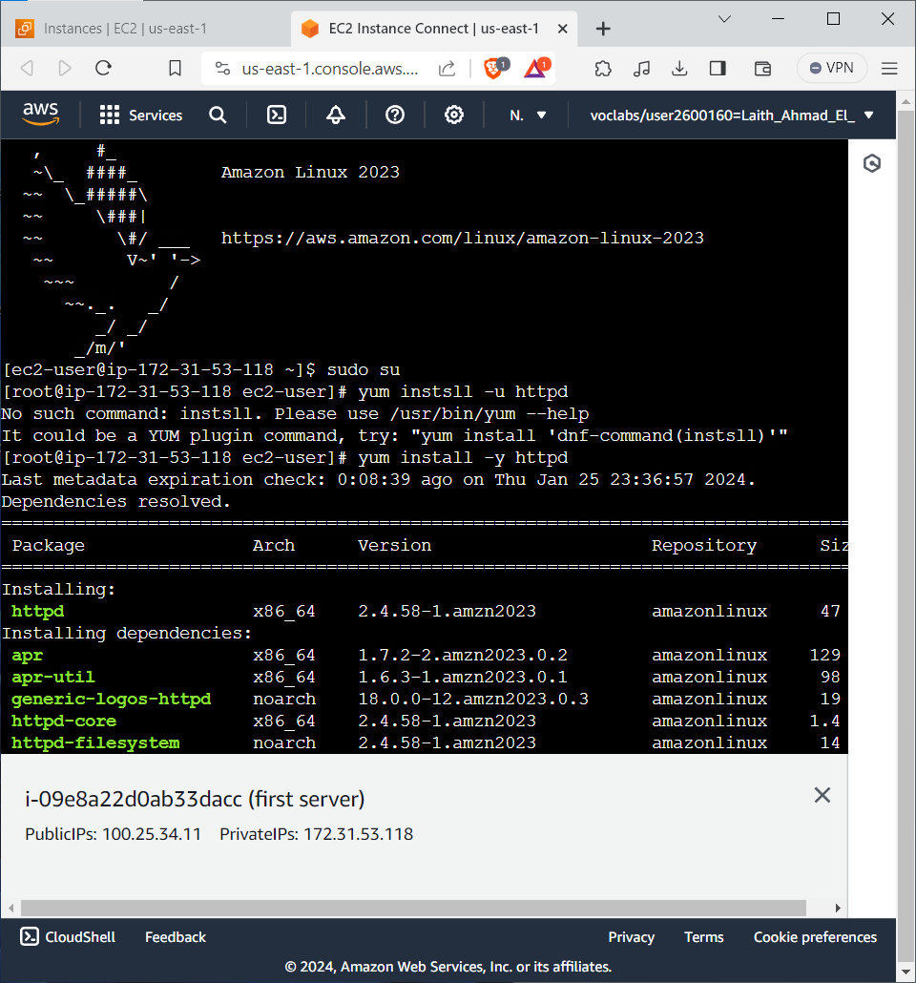

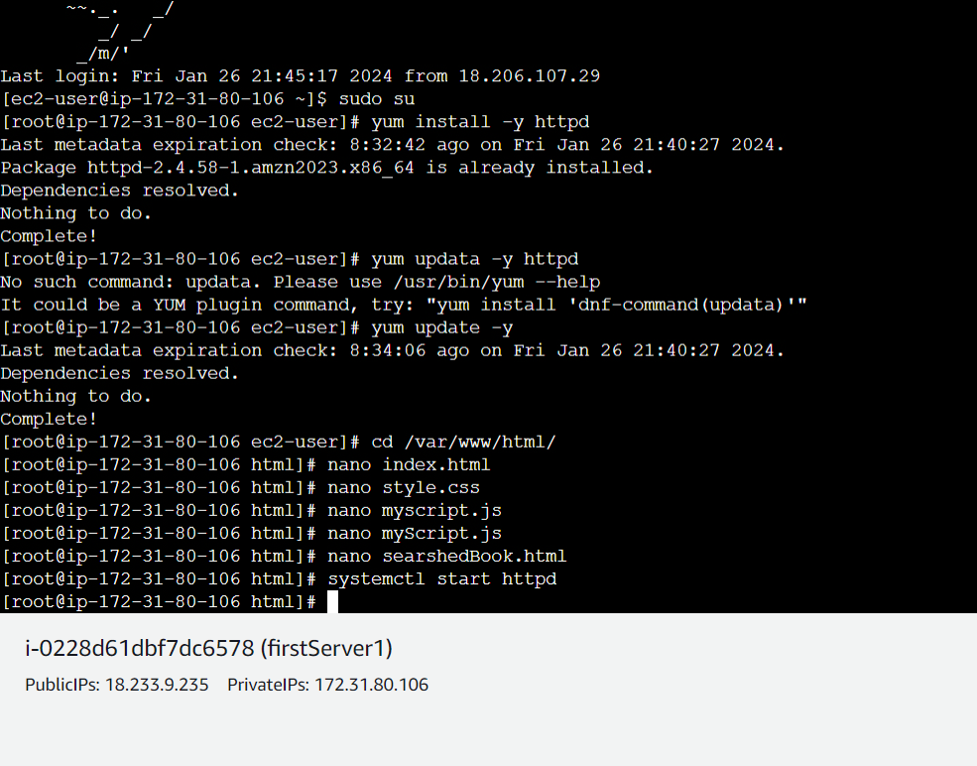

Thus, the website has been uploaded to the first server.

We repeat the same steps for the second server.

Website files are uploaded to the second server:

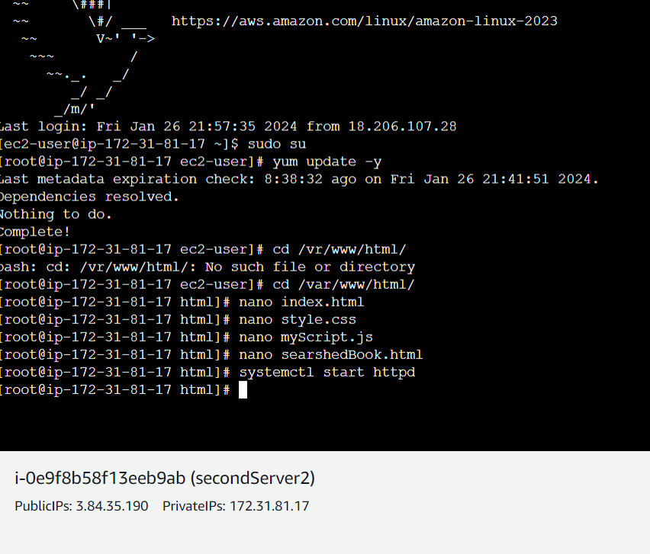

Whether the site has been successfully lifted on servers is checked:

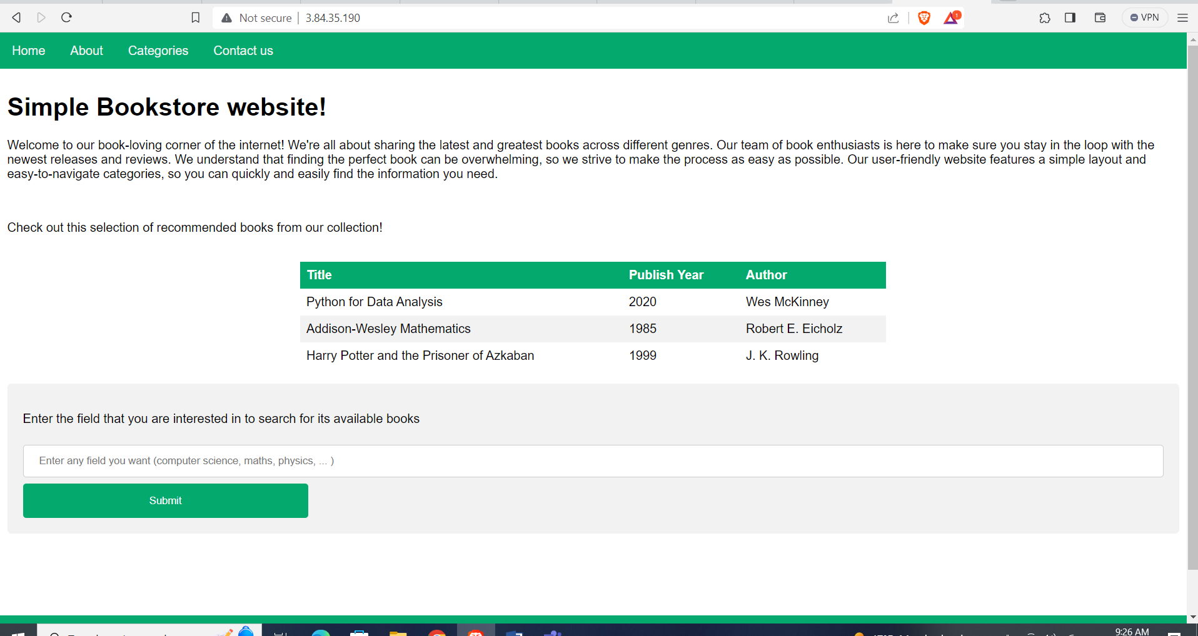

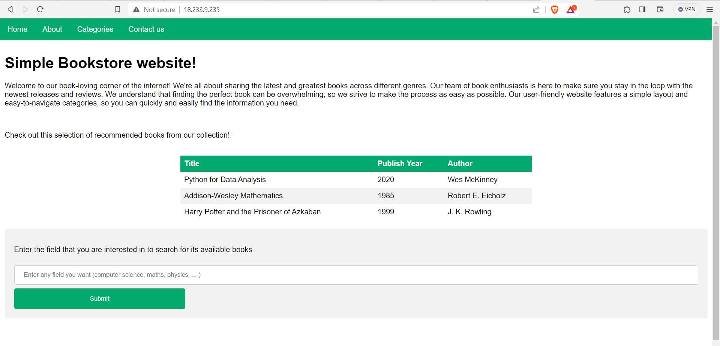

Creating a load balancer:

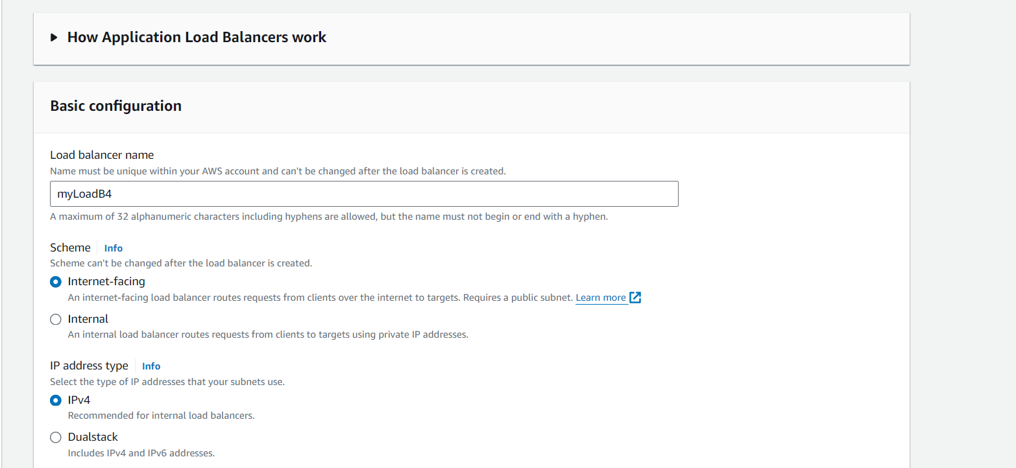

Add it to all availability zones:

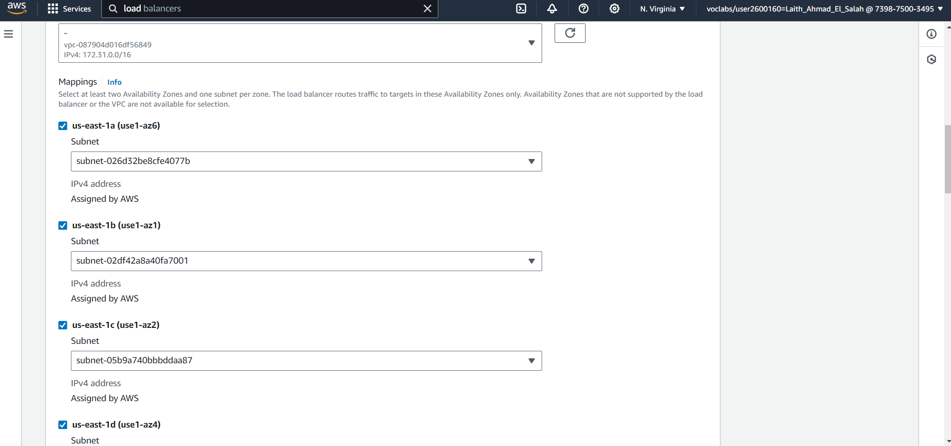

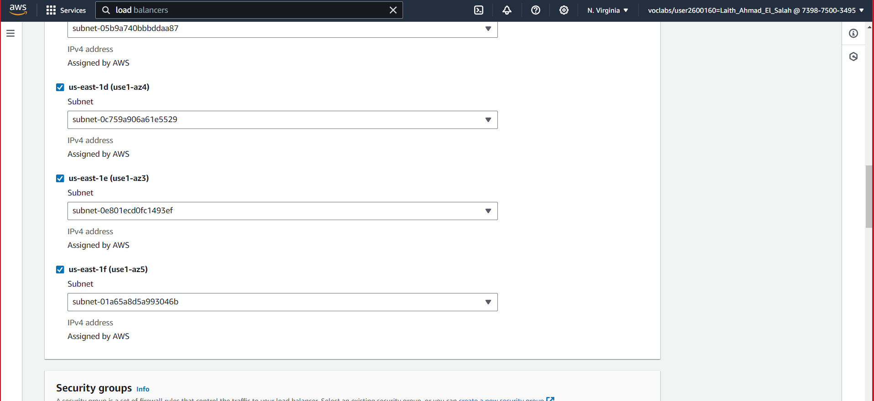

Add security group:  
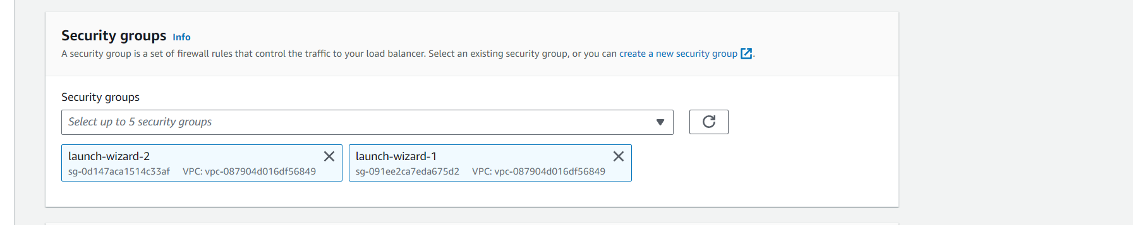

Add Target Group and detect healthey:

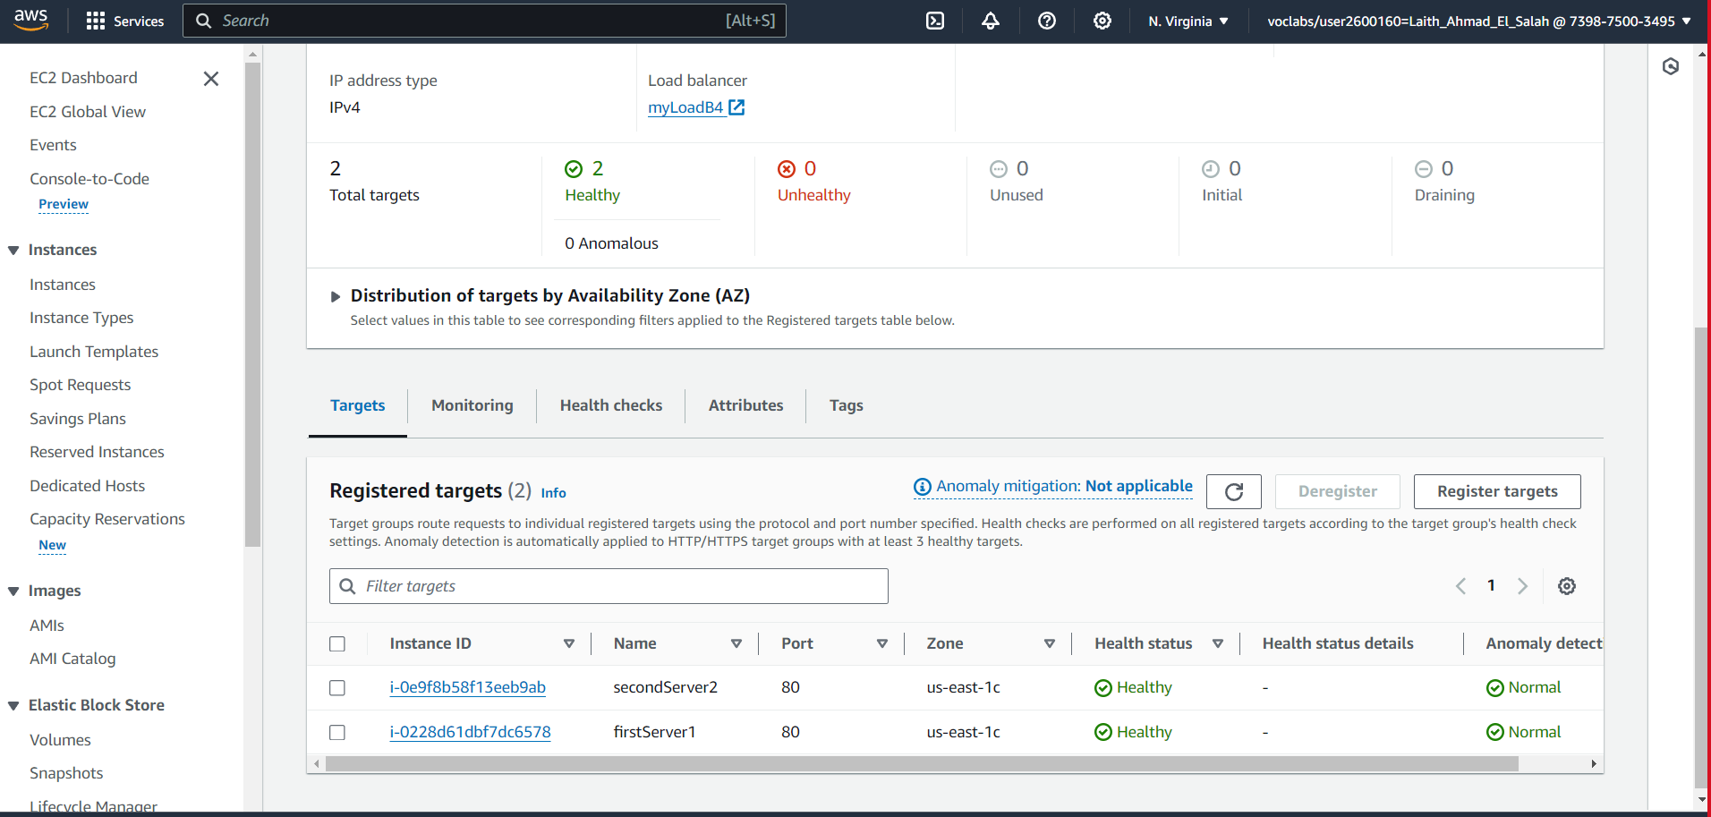

Test the site from DNS load balancer:

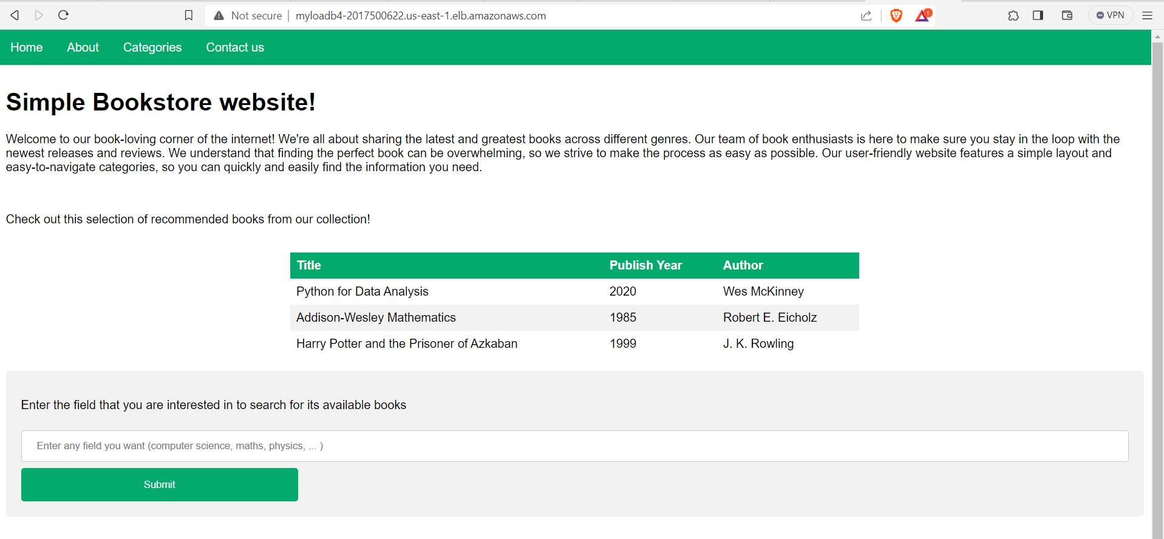

I also added bot control and SQL injection rules to increase security measures:

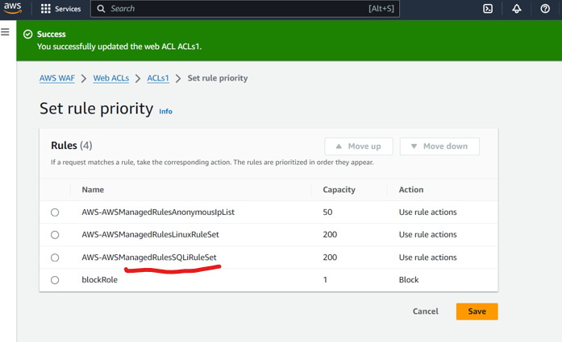

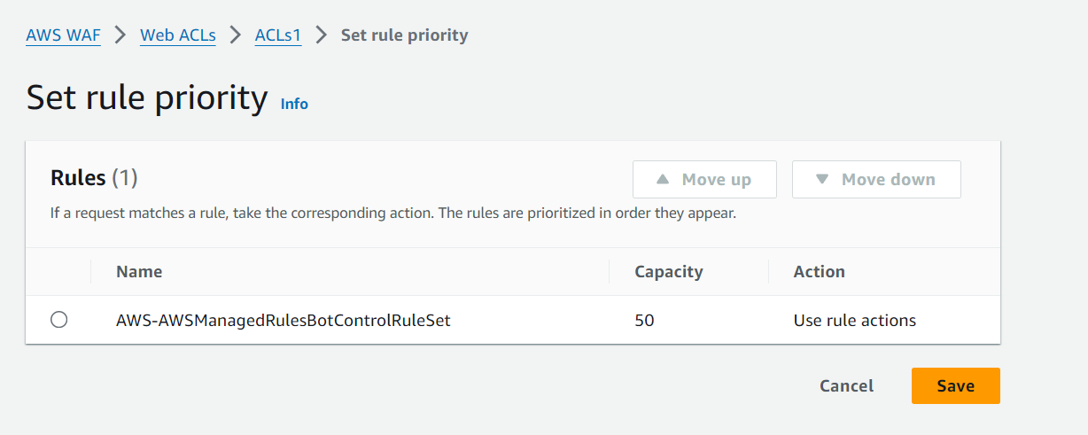

And now, add auto scaling

First, we create an AMI for the template

Then we add the template for the auto scaling settings

The function of the AMI is the operating system that I will add to the new server and the template is the new instant settings that I will make like the basic ones:

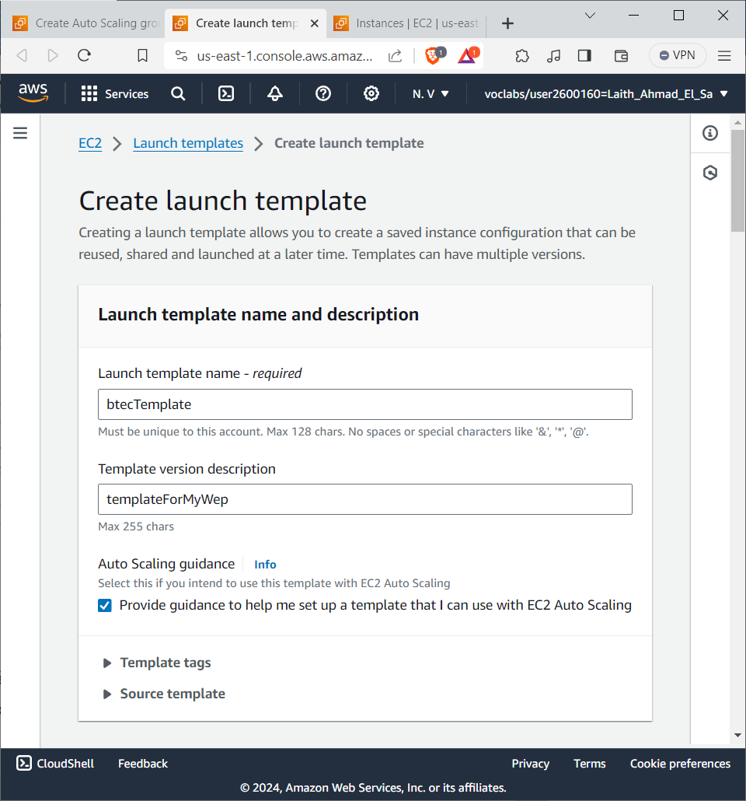

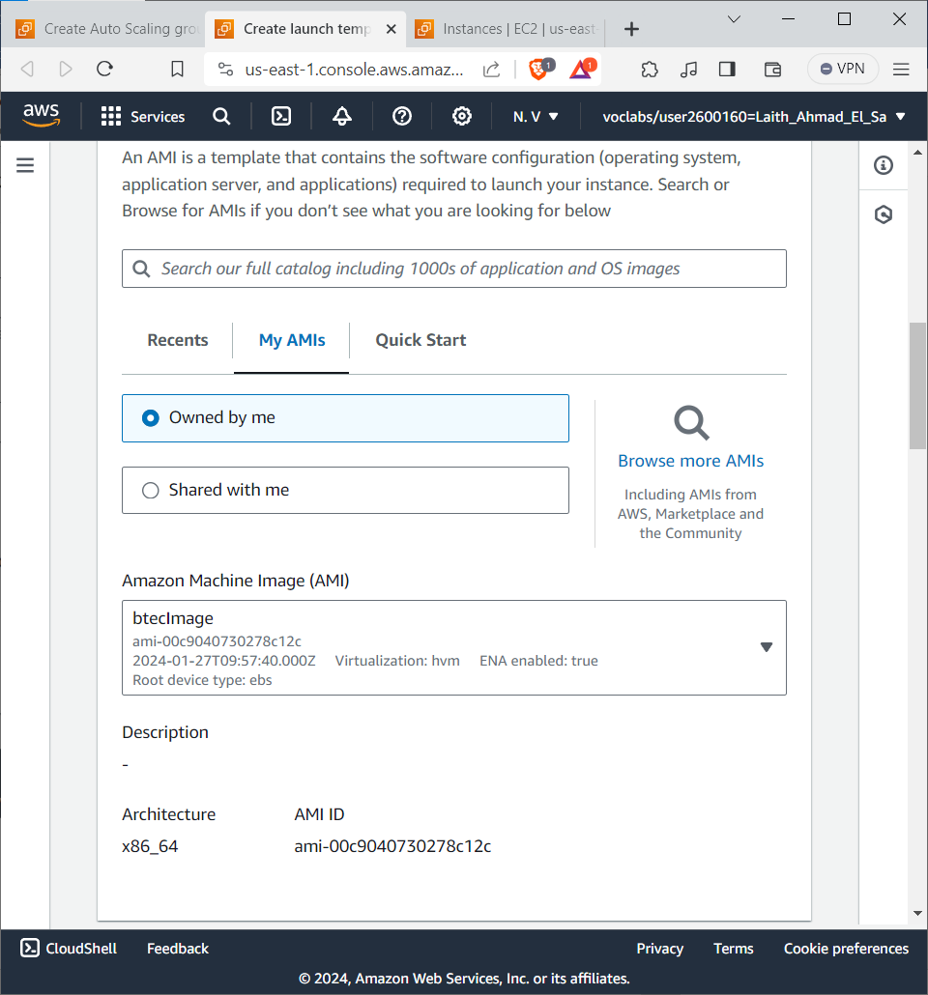

Based on the original servers

That is, before that, the auto scaling server settings are selected:

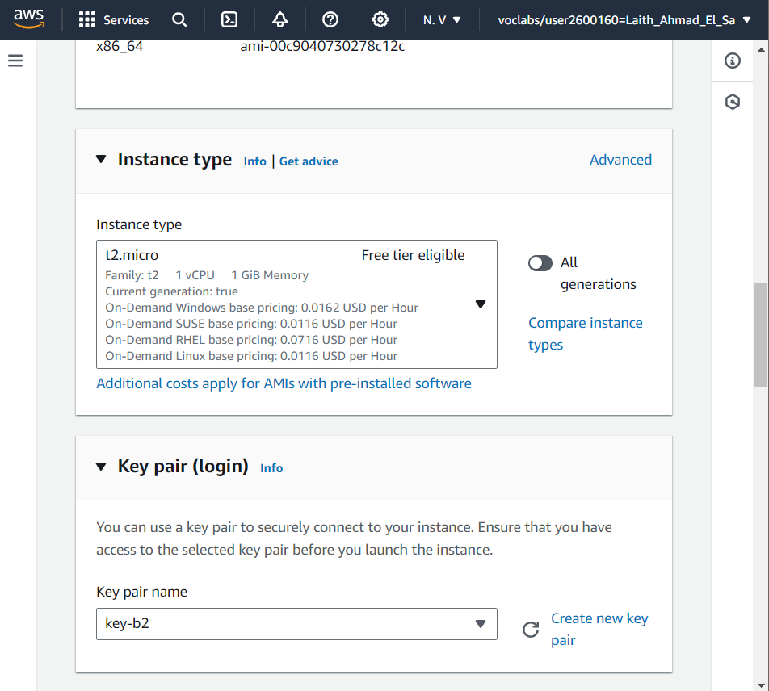

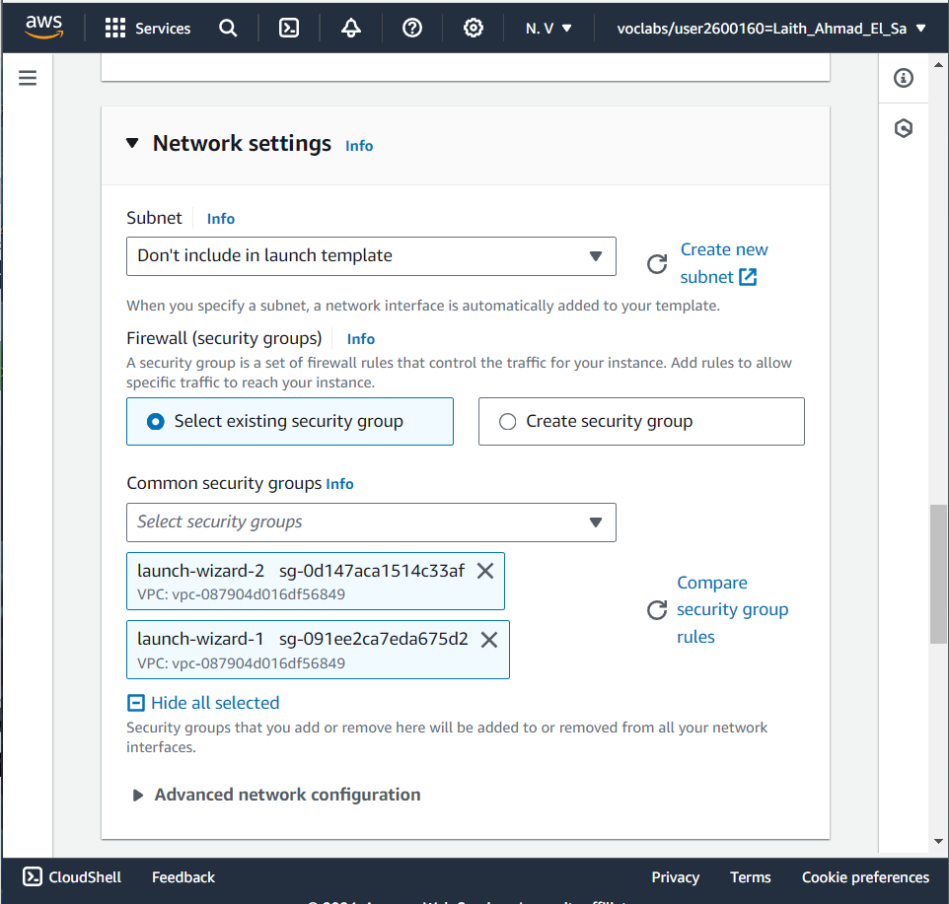

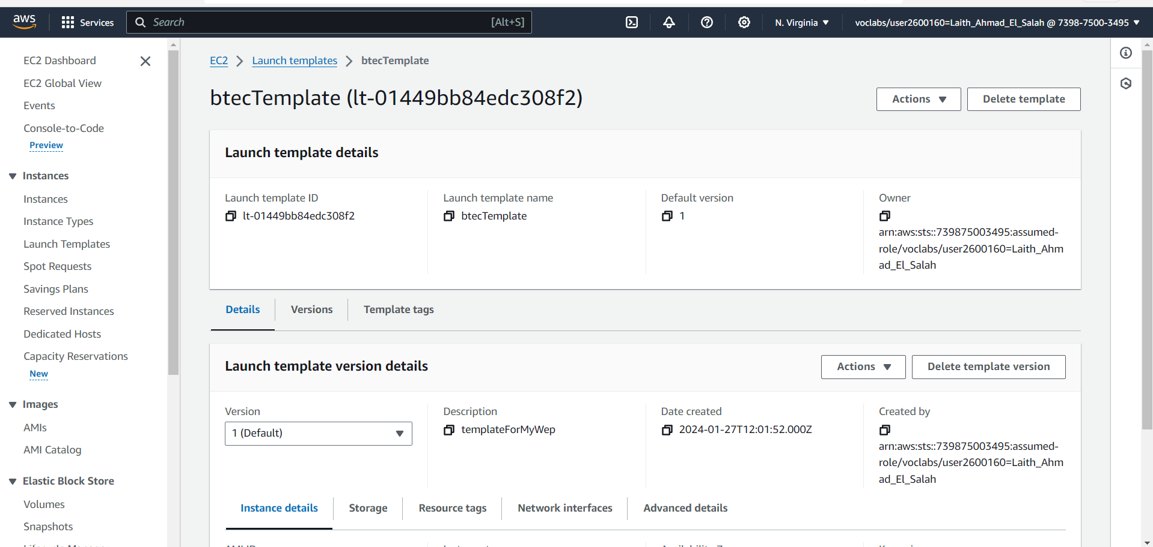

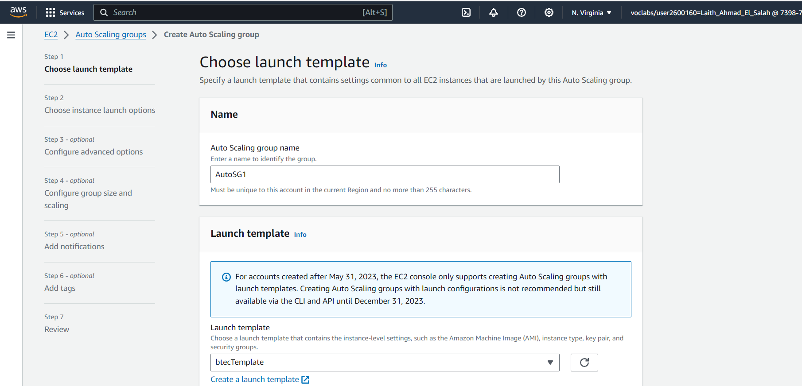

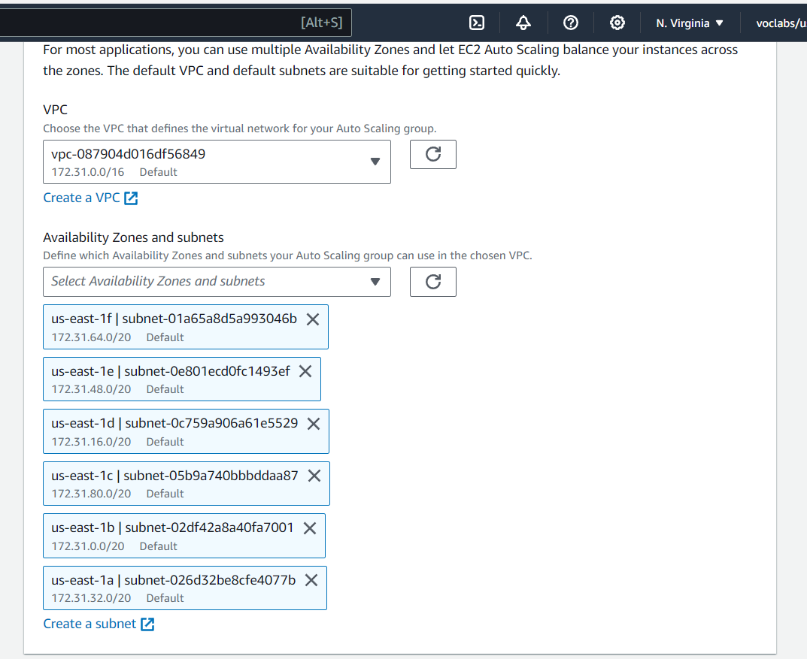

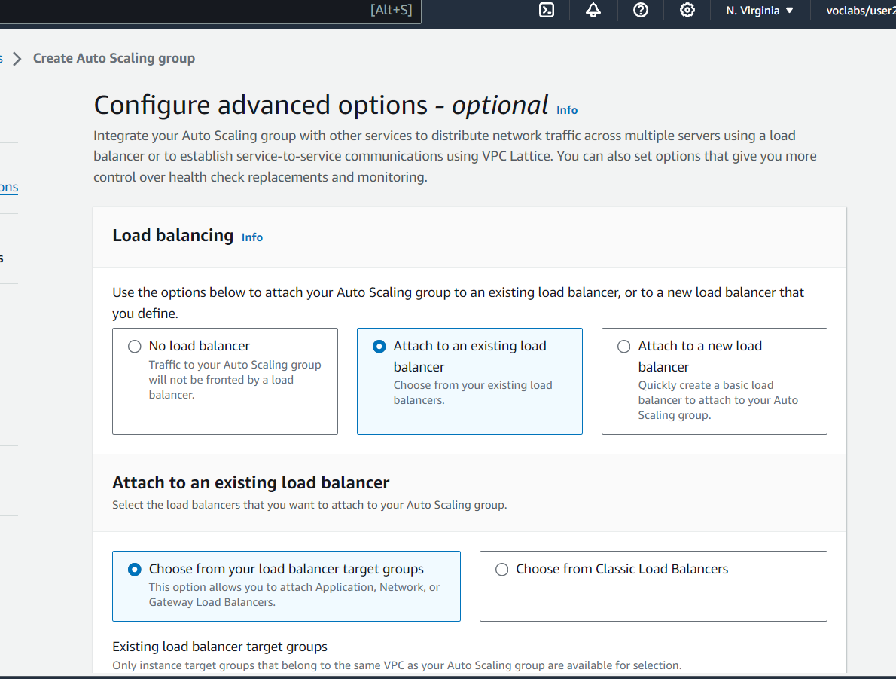

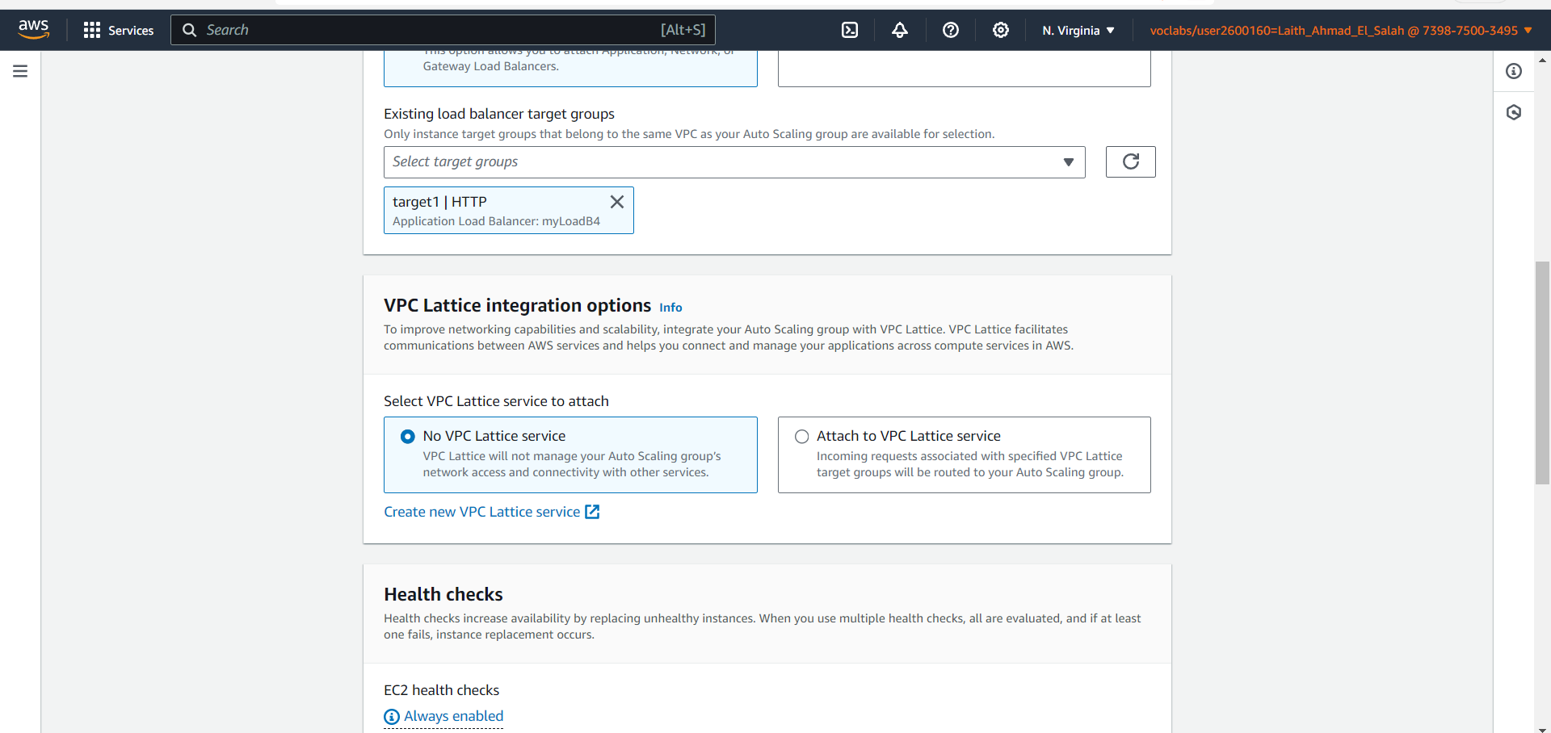

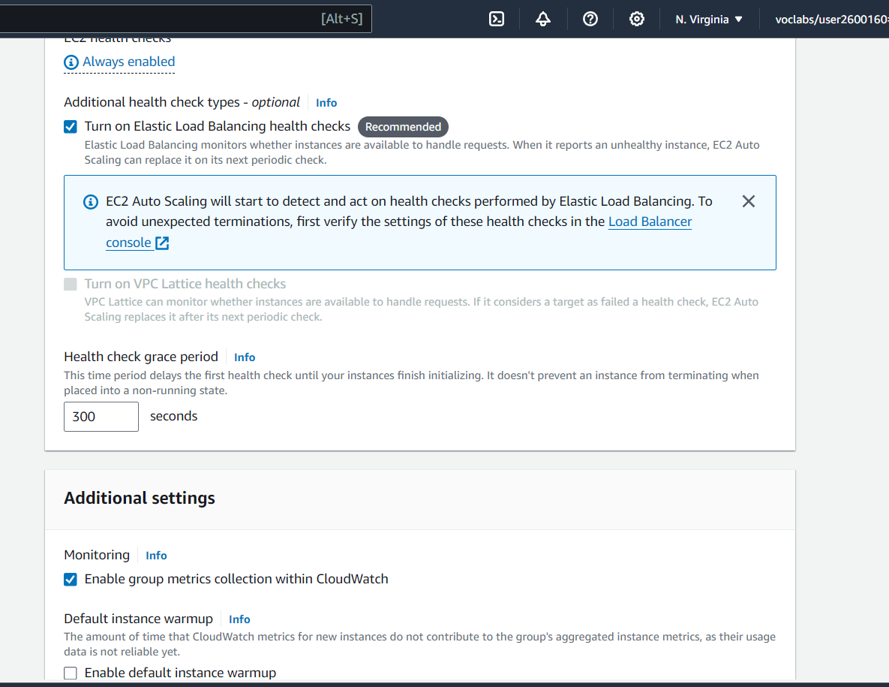

I chose two servers. When the pressure on the main servers increases, they will be activated. If there is pressure, the servers will be gradually increased until they become 6 in total. I chose to download the resources to one server as a minimum if there is no pressure on the server:

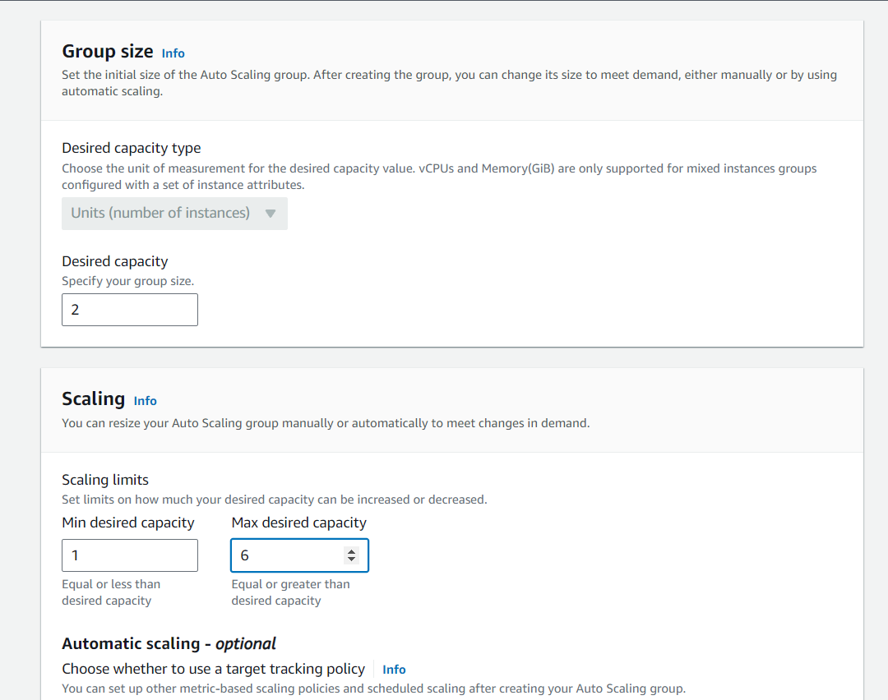

I chose that the number of requests, if it reached this limit, will be uploaded to these resources:

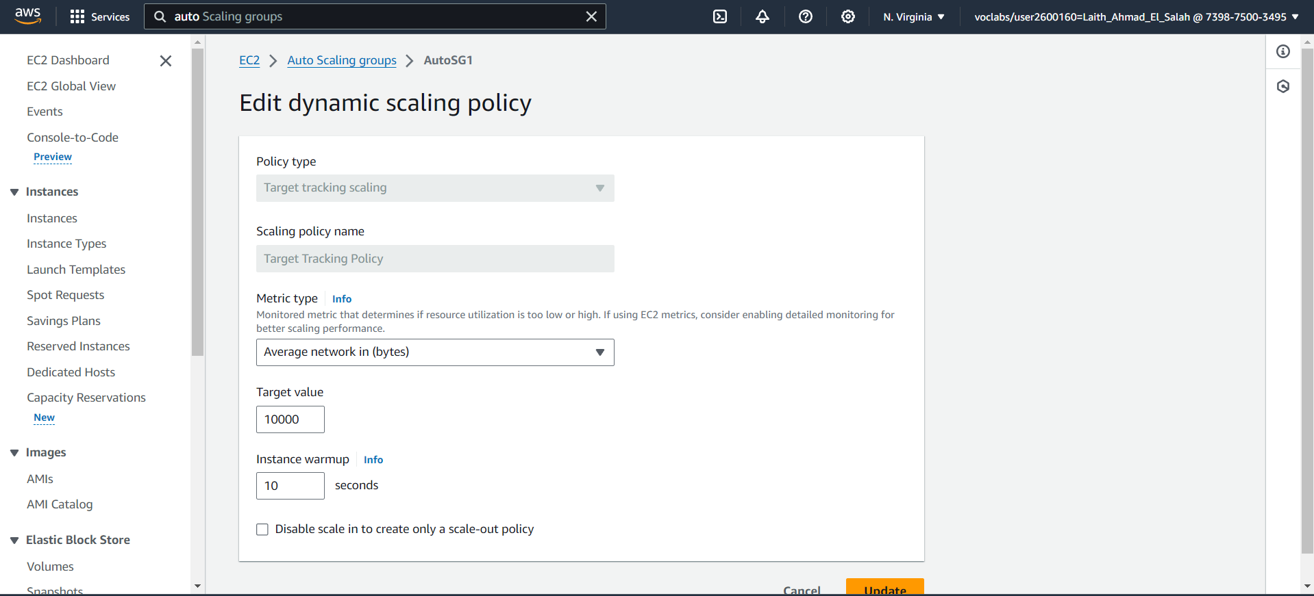

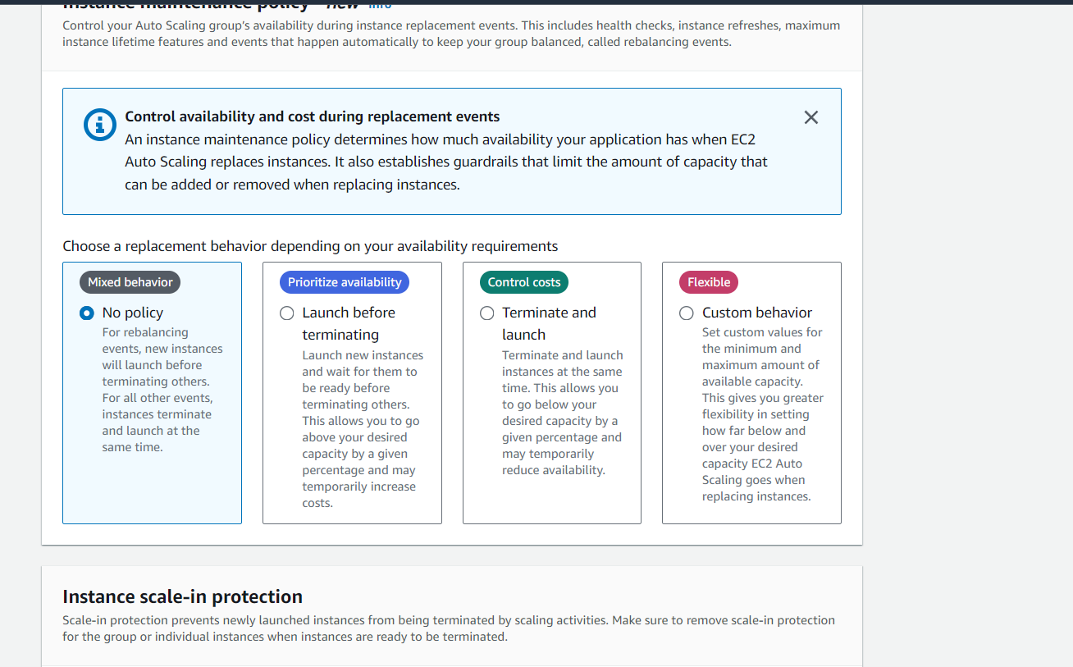

When resources were raised and new servers added:

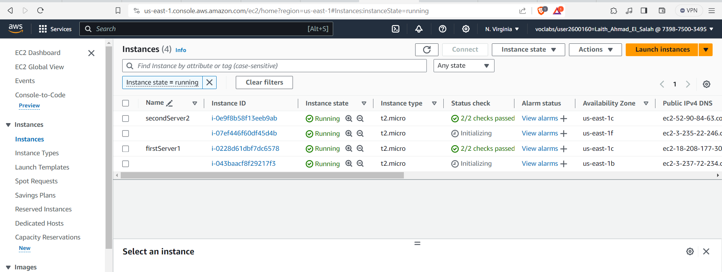

Now I'm going to add the appropriate rules because these rules help not to attack these data.

Add ACLs to improved protection procedures:

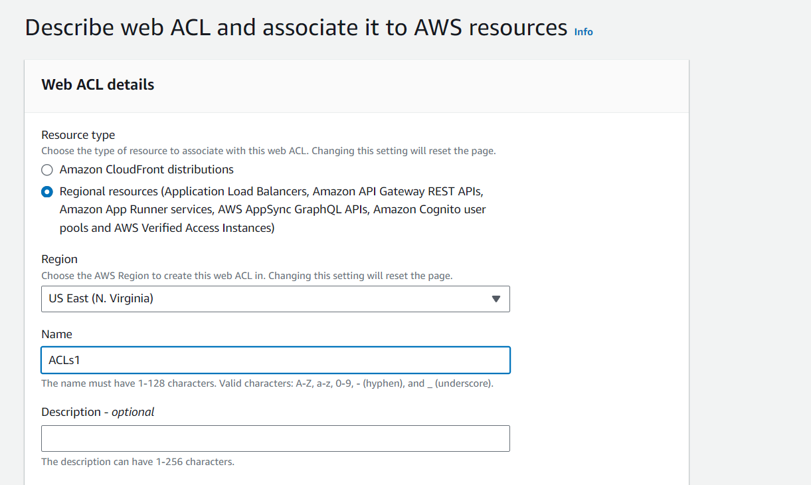

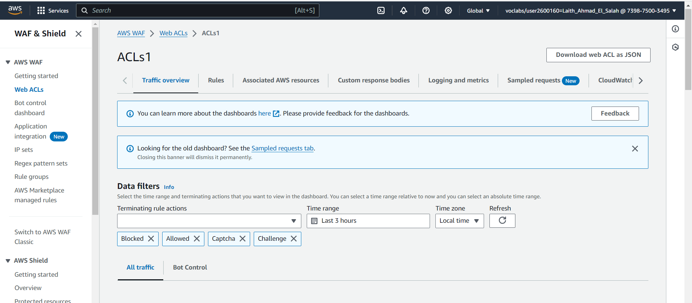

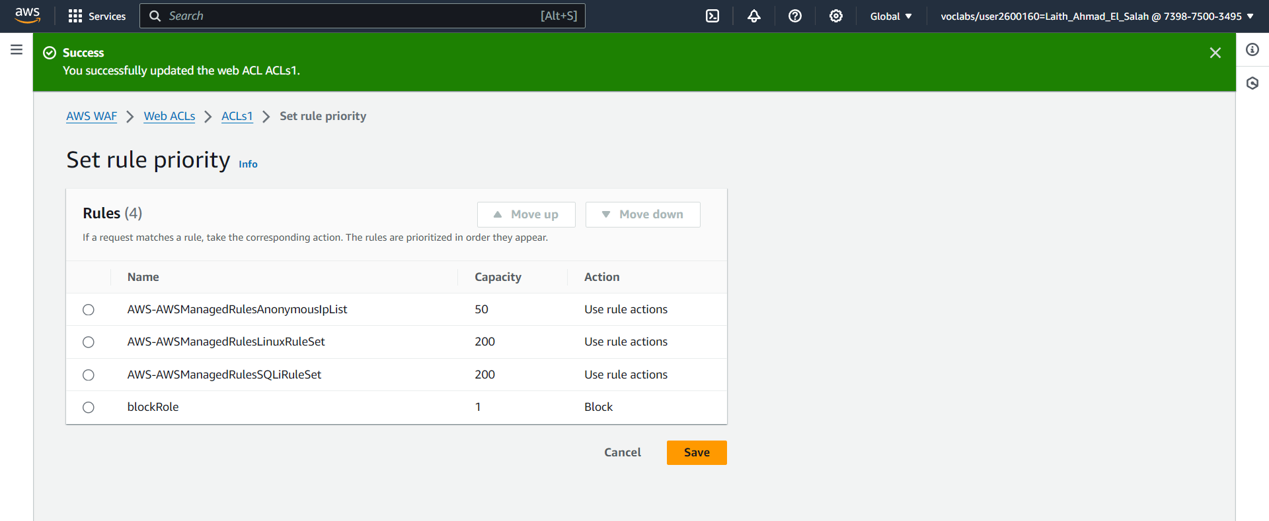



I have added these rules to:

1. AnonymusIPList: Blocks suspicious IP addresses: This blocks requests coming from IP addresses known to be associated with anonymization services.
2. Linux operating system: This rule blocks certain types of requests that attackers use to exploit vulnerabilities in Linux. For example, it can prevent local file inclusion attacks that reveal sensitive files or execute malicious code.
3. SQL database: This rule examines incoming web requests to your application and blocks those that match patterns associated with SQL injection attacks, such as injecting malicious SQL statements into database queries.
4. Block rule: This rule blocks suspicious IP addresses that are manually added.
5. Bot control: This is a set of rules managed by AWS aimed at protecting the application from bot attacks. This rule reduces the risk of bot attacks, such as Denial of Service (DoS) attacks.

**Task C: Comprehensive Testing of the Cloud System**

**As a final step, you have been tasked with conducting a thorough final test to improve and enhance the security and robustness of your cloud-based system. This involves developing, implementing, and reviewing your own test plans to recommend appropriate security enhancements.**

1. **Develop a comprehensive test plan for the security configurations you have implemented in the cloud-based system, with a primary focus on assessing the effectiveness of the security solutions implemented within the cloud.**

Conduct a test plan for each of the following:

Security groups

Load balancers

Access Control Lists (ACLs) from the WAF service

Auto-scaling groups

1. Test Title: Effectiveness Test of AWS Security Groups in Securing EC2 Instances

Description:

The test aims to evaluate the capability of AWS Security Groups to protect EC2 instances from unauthorized access and improve traffic control at the network level. This is achieved through a manual review of security group rules.

Objectives:

Ensure that security group rules only allow access to authorized resources.

Mitigate the risk of security attacks on EC2 instances.

Enhance traffic control between EC2 instances.

Tools:

Manual review of security group rules.

Methodology:

Manually review the security group rules to ensure they only allow access to authorized resources.

Test the security group rules by simulating different access scenarios.

Monitor system logs to record any suspicious activity.

Expected Results:

Prevent any unauthorized access to EC2 instances.

Record any suspicious activity in system logs.

Improvements:

Conduct comprehensive tests for various access scenarios.

Analyze test results to identify any weaknesses in security group rules.

2. Test Title: Load Balancers’ Capacity Test for Load Distribution and Traffic Management

Description:

The test aims to measure the ability of load balancers to handle a high number of concurrent requests without causing interruptions or slowdowns.

Objective:

Ensure the load balancers’ ability to distribute traffic efficiently even under heavy load conditions.

Enhance user experience by maintaining fast response times.

Tools:

Load testing tool (e.g., JMeter) and using the DNS name.

Methodology:

Verify that servers are functioning correctly.

Ensure that load balancers are operational.

Monitor traffic distribution across servers.

Send an increasing number of requests to the load balancers.

Monitor load balancer performance by measuring response time and error rates.

Expected Results:

Load balancers can process all requests without interruptions or slowdowns.

Maintain fast response times even under heavy load conditions.

Improvements:

Use specialized tools to monitor load balancer performance.

Conduct comprehensive tests for various load scenarios.

Analyze test results to identify any weaknesses in load balancer performance.

3. Test Title: Effectiveness Test of WAF ACLs in Protecting the System

Description:

This test aims to evaluate the ability of WAF ACL rules to protect the system from attacks. This is achieved through manual inspection of ACL rules or using a WAF tool.

Objective:

Ensure the ability of ACL rules to block or intercept any suspicious or malicious traffic.

Protect the system from potential damages such as data breaches or service disruption.

Tools:

WAF tool

Manual review of ACL rules

Methodology:

Manually review ACL rules or use a WAF tool.

Test each rule by simulating various attacks.

Monitor system behavior and log any suspicious activity.

Expected Results:

Block or intercept all attacks targeting the system.

No suspicious activity in system logs.

Improvements:

Conduct comprehensive tests for various types of attacks.

Analyze test results to identify any weaknesses in ACL rules.

4. Test Title: Efficiency Test of Auto Scaling Group in Traffic Adaptation

Description:

This test aims to evaluate the ability of the Auto Scaling Group to effectively and quickly scale instances up or down in response to traffic changes. This is done by applying a heavy load to the Auto Scaling Group and monitoring its response.

Objective:

Ensure the ability of the Auto Scaling Group to adapt to traffic changes without interruptions or service slowdowns.

Ensure the website is efficiently available to all users at all times.

Tools:

JMeter

CloudWatch

Methodology:

Configure the Auto Scaling Group settings to define thresholds for scaling up or down.

Apply heavy load to the website using JMeter.

Monitor the performance of the Auto Scaling Group using CloudWatch.

Expected Results:

Effectively and quickly scale up the number of instances when reaching a certain traffic threshold.

Effectively and quickly scale down the number of instances when traffic decreases.

No interruptions or slowdowns in service during the load test.

Improvements:

Conduct comprehensive tests for various load scenarios.

Analyze test results to identify any weaknesses in the Auto Scaling Group's performance.

1. **Implement the testing methodology you have developed on the configured cloud-based system. This task involves providing a clear description and appropriate screenshots of the steps you followed in your testing.**

In these images, I have masked the SQL injection rule and tested whether it was effective and if the test was successful.

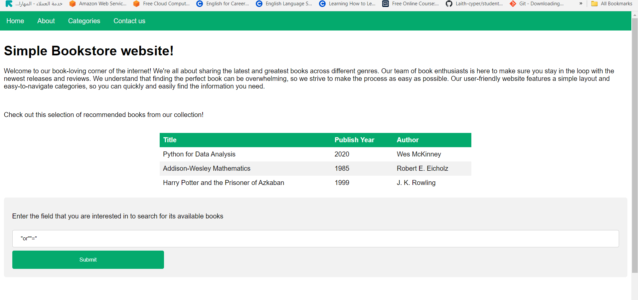



In this photo I tried the load balancer and the test succeeded:

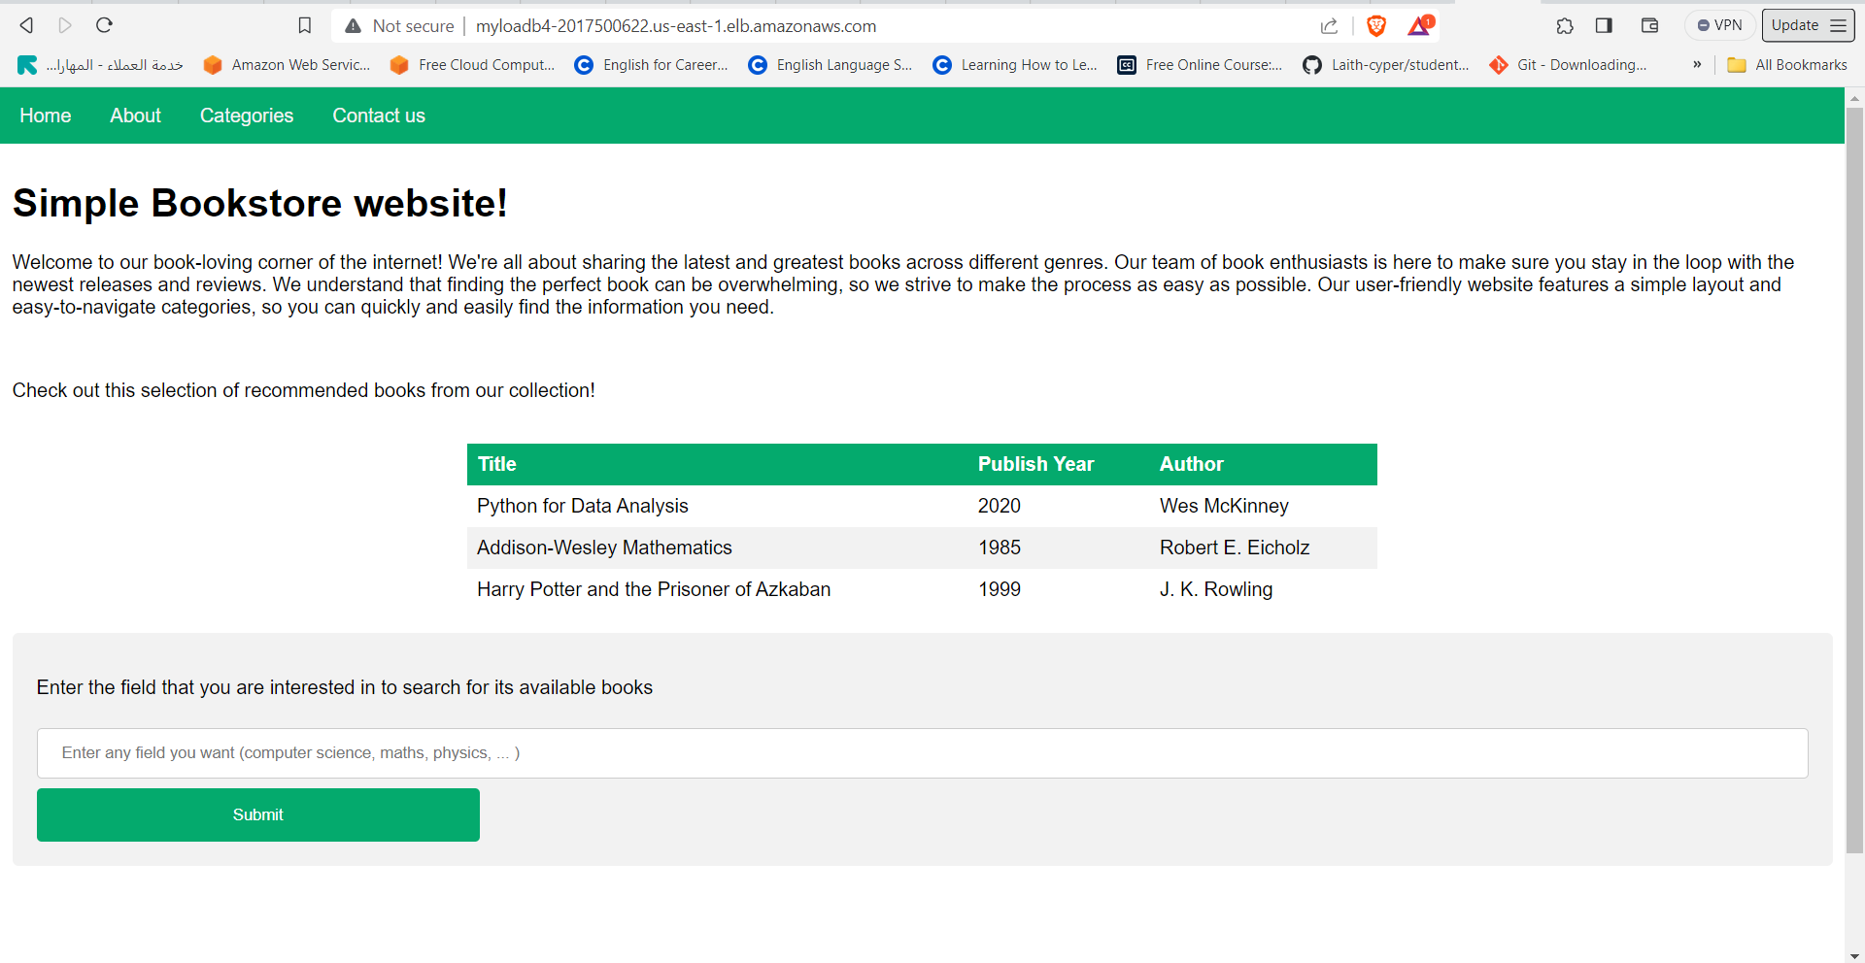

In these pictures, I tested the auto scaling group before sending requests to it and after, will the servers increase or not? The test was successful. I set the number of requests to 10,000 :



This image shows the amount of requests to the servers before starting to test them and increase the load on them:

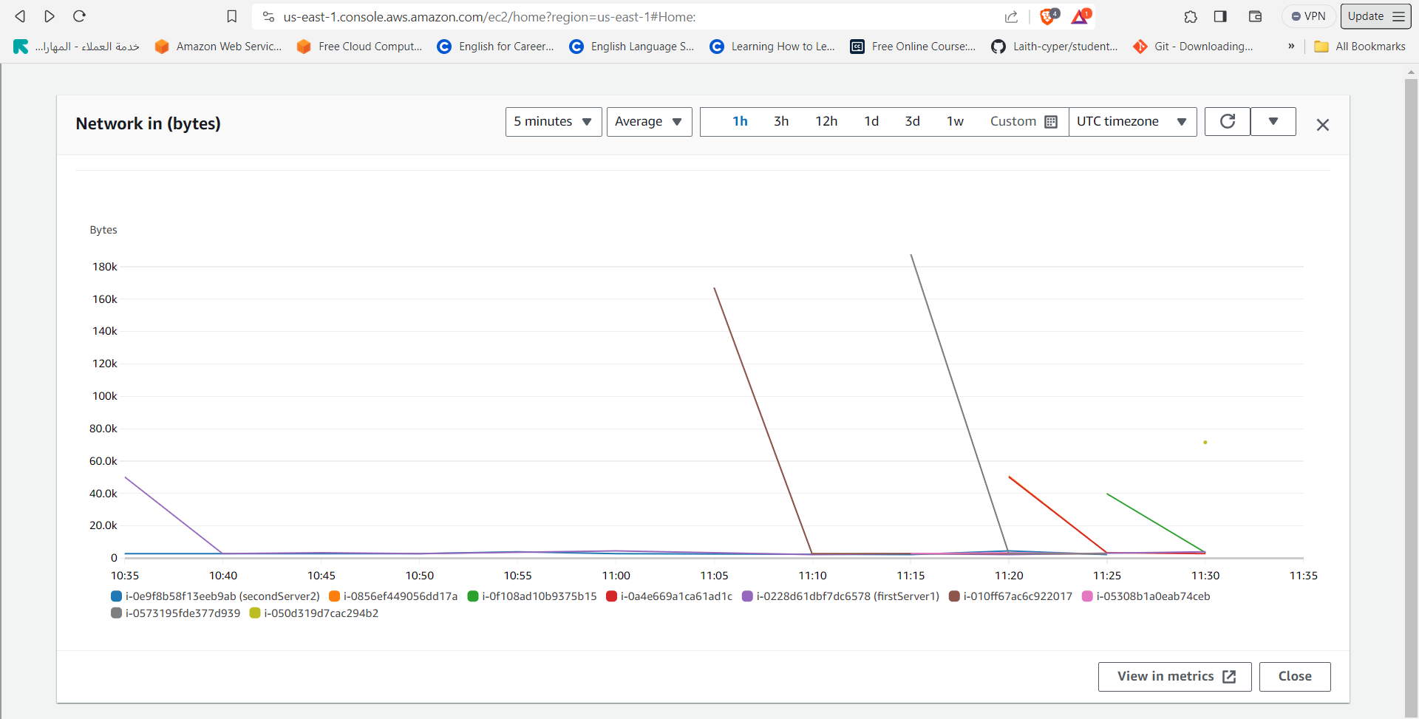

These pictures are for auto scaling test and it worked:

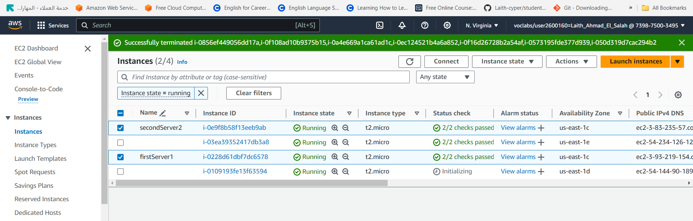

By Jmetar requests were sent to the server:

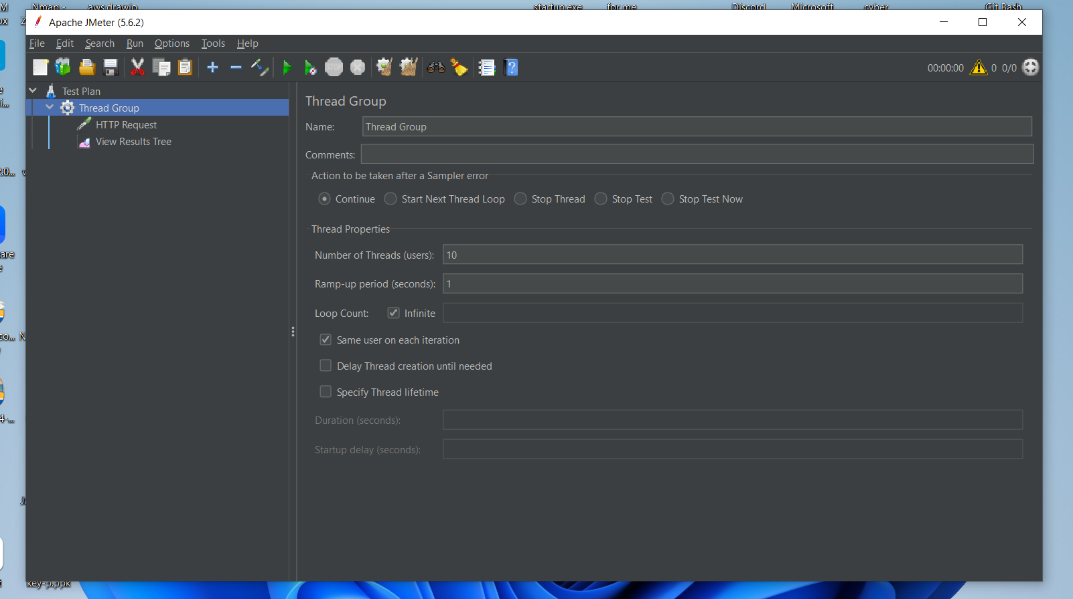

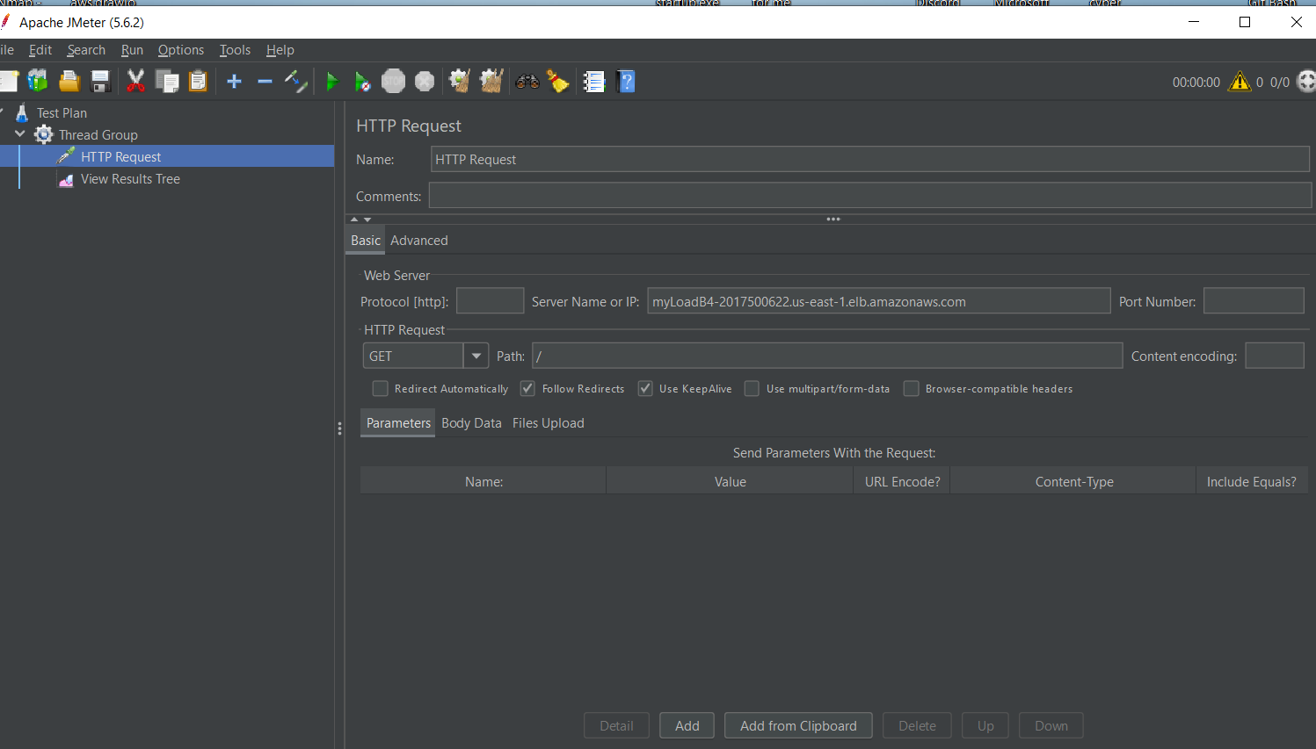

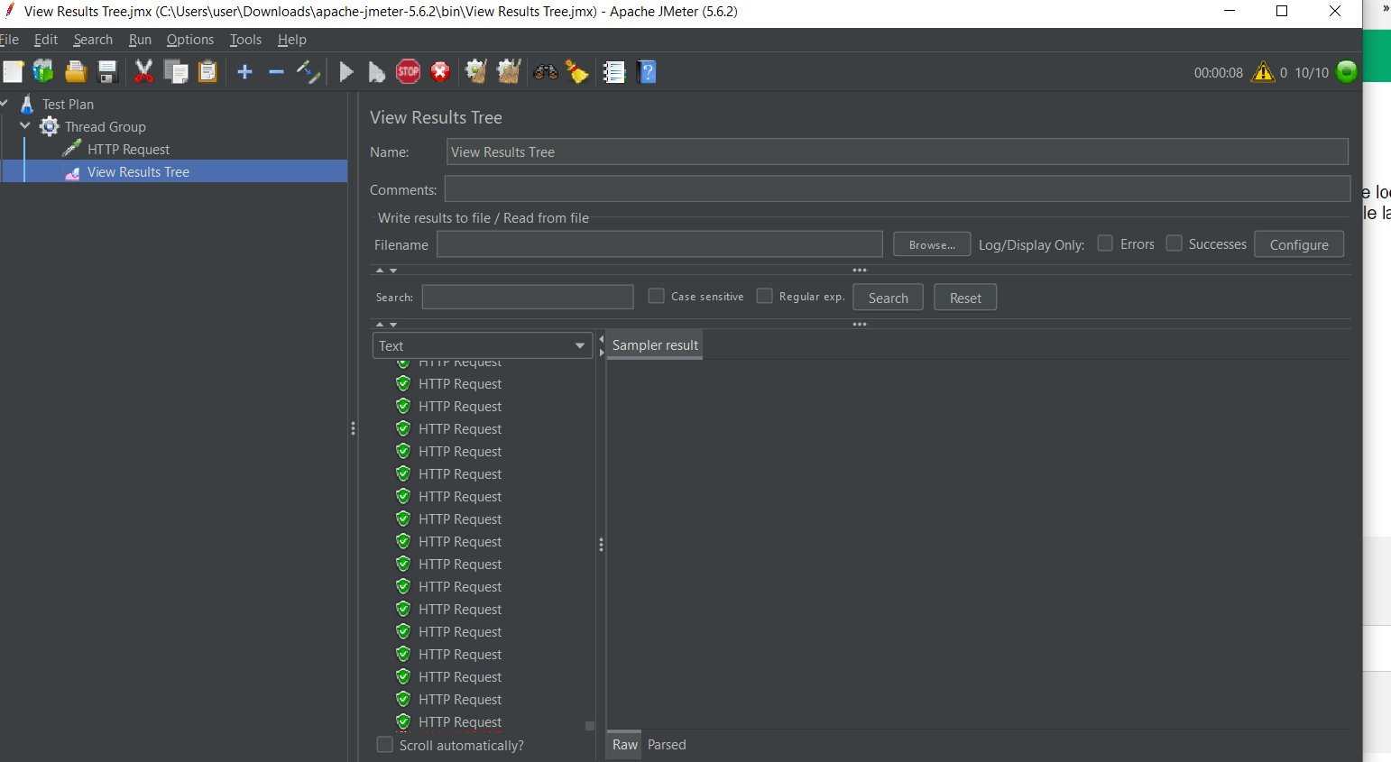



After sending requests to the server, all 8 servers were started:

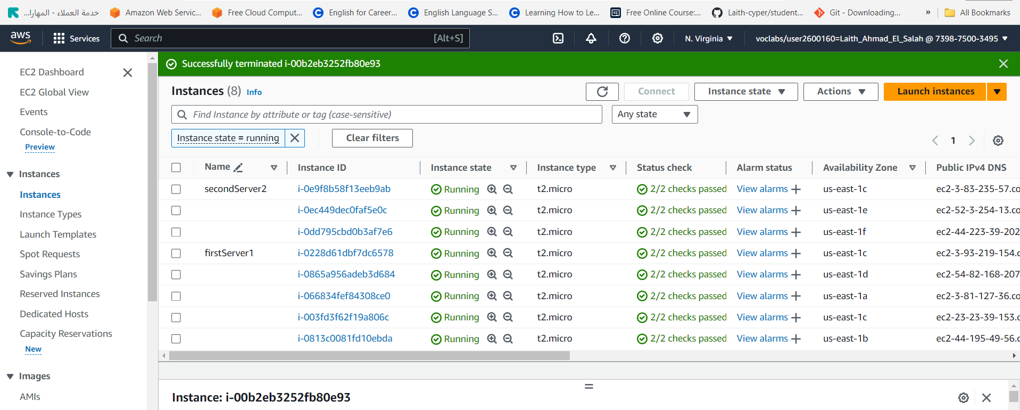

This image shows how the criteria differed between the two images and the amount of requests:

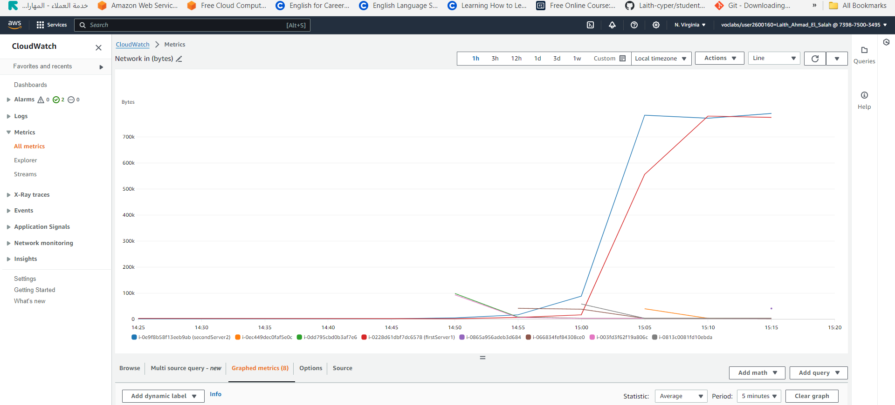

Here I blocked this IP as it is suspicious and may pose a risk:

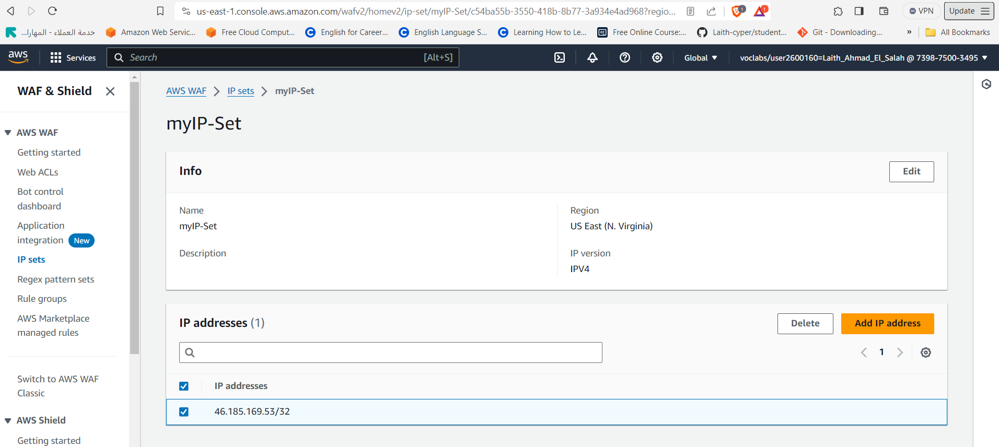

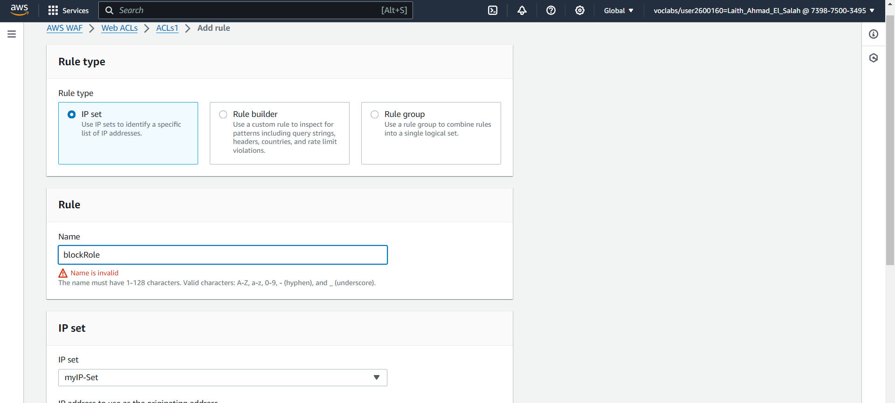

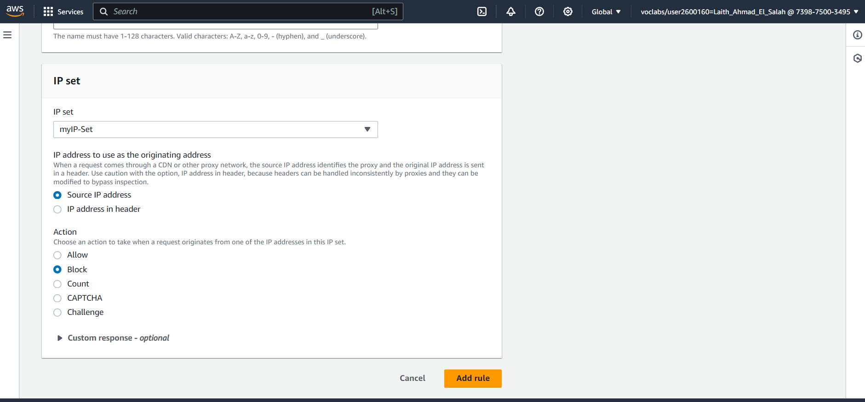



In these pictures I checked the security suite to see if it is working. Since I had allowed access to the server via the http port, I should be able to access the website:

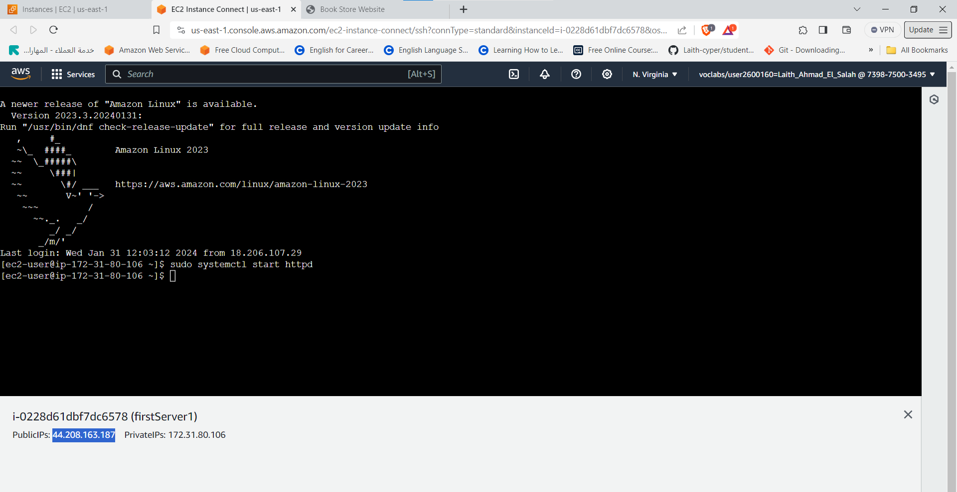

The site turned out to be working and now I will close the http port and make sure that I cannot access the website:

And now I've deleted the http port:

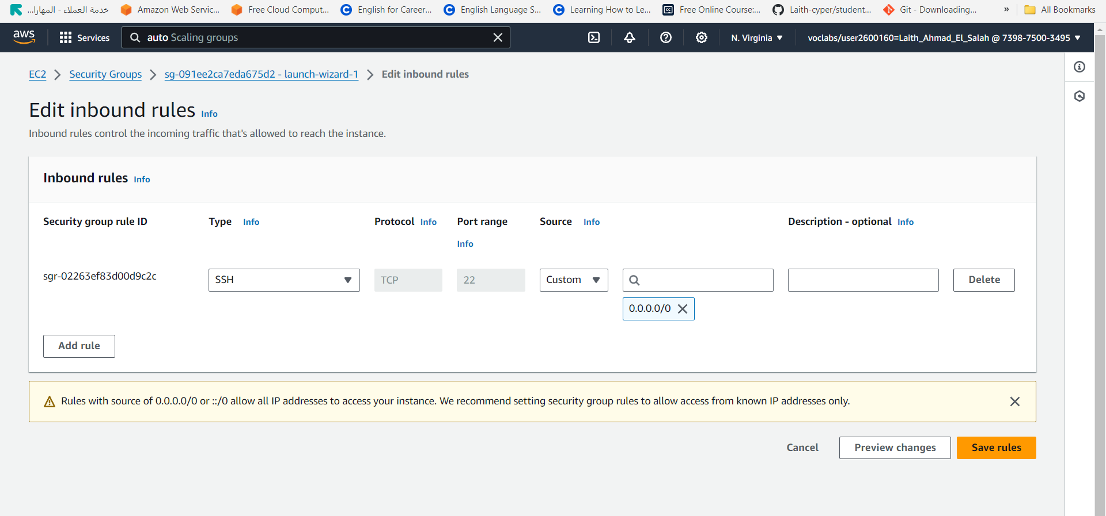

It seems that the security suite was working fine because I could not access the site after closing the http port:

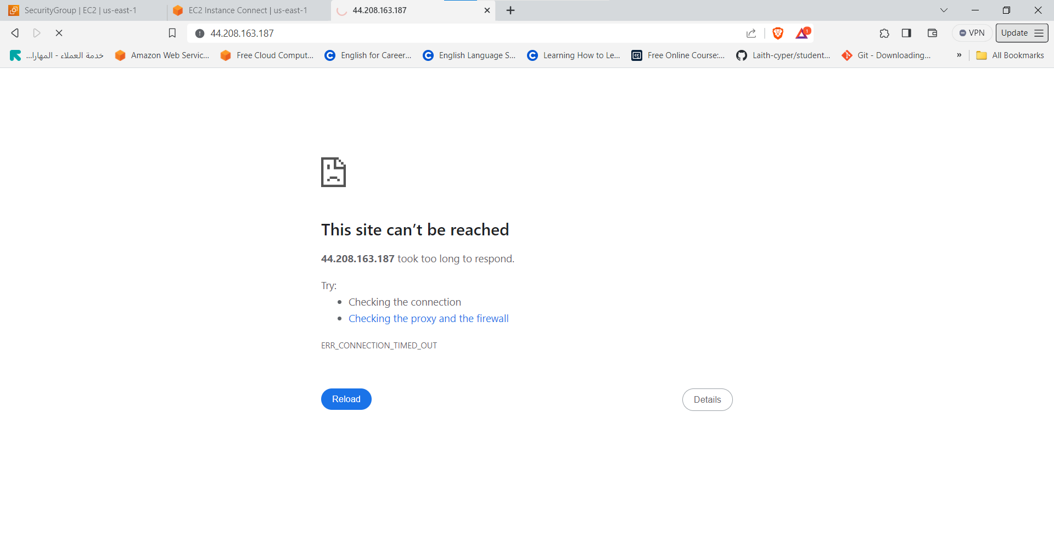  
  
After the port is restored, access to the web page is restored:

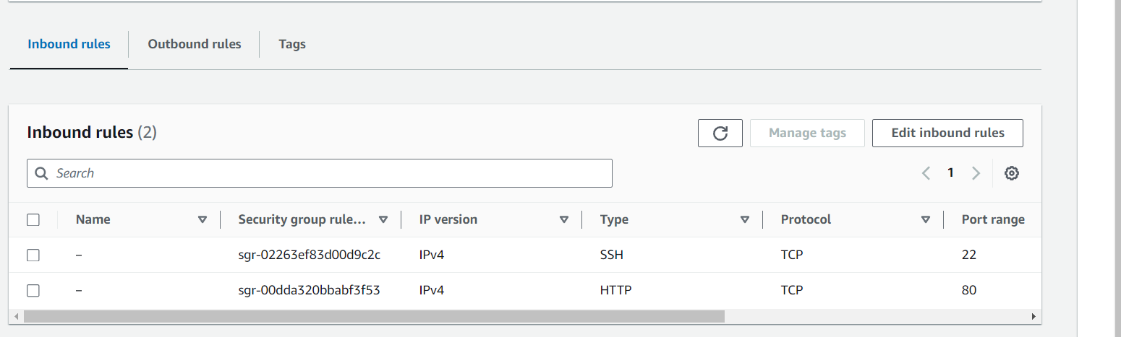

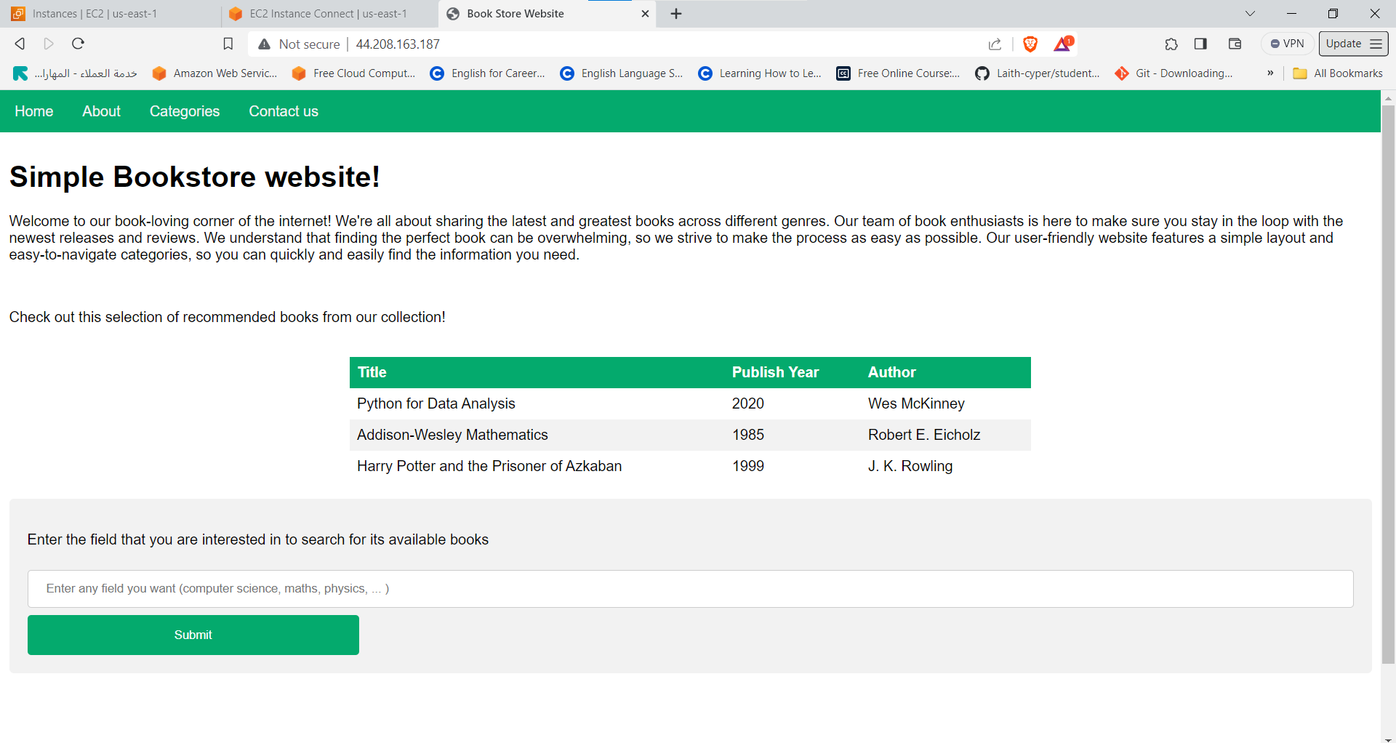

Here are some pictures of the bot control base experience:



After setting the rule, I made sure that the rule was working by entering the site via the DNS load balancer. After I made sure that the rule was working, I decided to test it by sending requests via jmetar. It turned out that the rule was also working because it blocked the requests because the site requests verification that the person sending the requests is a human or a bot:

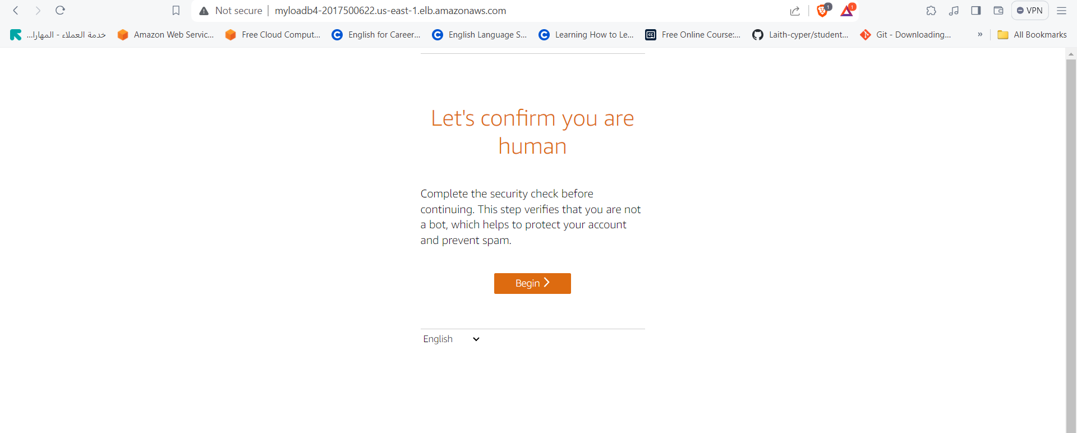

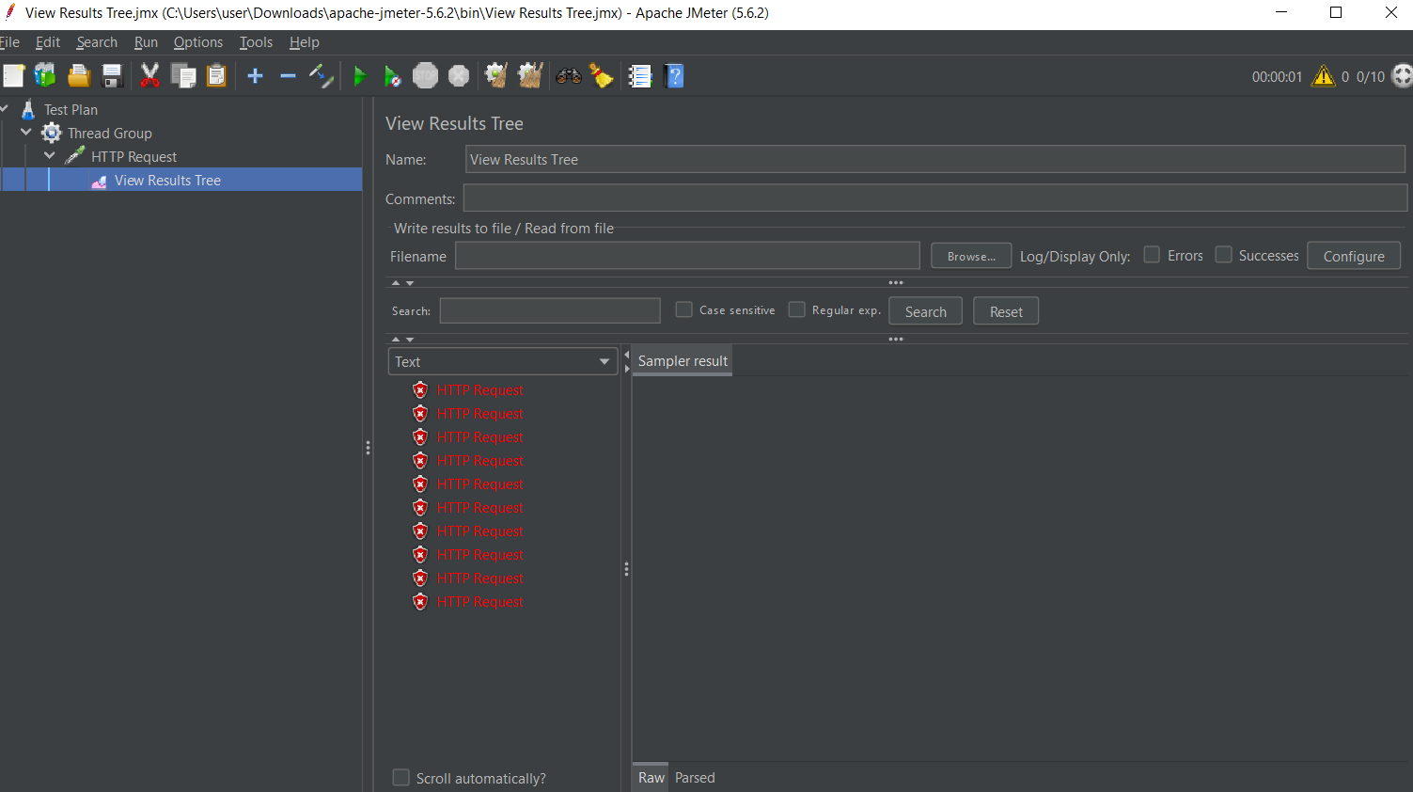

1. **Select the results of your test and make recommendations to enhance the cloud security of your configured system. Next, use SWOT analysis method to systematically investigate your security test results.**

Security tests have shown that the site has a good level of security and there are some steps you can take to enhance its security further.

Security Groups can be improved in several ways to enhance security and improve protection for applications and resources:

* Minimize group rules, i.e. keep the number of group rules to a minimum because the more rules there are, the more complex they are to manage and the more likely they are to create security vulnerabilities.
* Security group rules should be reviewed regularly to ensure that they still fit current security and application requirements.
* Break security groups into smaller units according to different functions or applications. This makes them easier to manage, understand, and define permissions accurately.

Some additional enhancements to Load Balancer that help improve performance, security, and resilience:

* Use SSL/TLS Offloading: Configure the load balancer to handle SSL/TLS encryption in offloading mode, reducing the load on web servers and improving system performance.

Enhance AWS WAF Access Control Templates (ACLs):

* Define and classify rules based on their importance and sensitivity, and configure priorities based on this classification to properly route traffic.
* Regularly review and improve ACLs to keep up with the latest threats and security updates.
* Use AWS WAF Geo Match Conditions: To block addresses from a specific geographic region if you do not want that region to access your site/application.

Optimizing Auto Scaling Group in AWS:

* Periodic improvements: Regularly review and optimize Auto Scaling Group configurations to ensure optimal performance as application requirements and load changes.
* Continuously monitor Auto Scaling Group performance and analyze costs to ensure that optimal performance is achieved at the lowest possible cost.

Some additional improvements that can be followed:

* Using AWS security services such as AWS Identity and Access Management (IAM) to enhance protection and monitor activity.
* Use AWS Cost Explorer and AWS Budgets to monitor and analyze costs and identify opportunities for cost optimization.

Human resources improvements in the Amazon Cloud (AWS) environment: By providing comprehensive training on AWS services, providing training on AWS best practices, providing training on problem-solving skills, building a multi-skilled team, and hiring engineers with expertise in information security.